第五单元教案
Unit 5 Do you have a soccer ball?

教学内容：
本单元主要学习动词have的一般现在时的用法；使用do和does引导的一般疑问句的构成以及简单回答。以“和朋友一起欢度时光”为话题：列举所学的运动项目，从中挑选出各自喜欢的体育项目，目的是巩固并新学一些体育项目的名词；并让学生互相询问所爱好的运动，并根据情况发出邀请，掌握用do和does引导的一般疑问句的构成及使用，了解用Let’s提建议的句型。
教学目标
学会用have对物品的所属进行提问与回答；学会用let’s…句型提建议；能够谈论自己喜欢哪些球类运动，不喜欢哪些球类运动及原因；能够谈论怎样和自己的朋友度过一段愉快的时光，并且能运用本单元所学的句型和体育项目名称写篇文章。以达到进一步复习复习和巩固的目标。

教学重难点
行为动词have的一般现在时的用法；使用do和does引导的一般疑问句的构成和使用。
词汇
Have，soccer，ball, tennis, racket, ping—pong, volleyball, basketball, bat, dose, doesn’t , let, us let’s play, well, sound, good, sport, we, many, club, more, class, interesting, boring, fun, difficult, relaxing, watch, watch TV, great, collection, but, play sports, only, them, every, day
句型
Do you have a TV? Yes, I do. /No, I don’t.
Do they have computer? Yes, they do. / No, they don’t.
Does he /she have a soccer ball? Yes, he/she does. No, he/she doesn’t.
Does Chi young have a baseball? Yes, he does. No, he doesn’t.
Let’s play soccer. I don’t have a soccer ball.
Well, Let’s play volleyball. That sounds good.

教学设备：多媒体、录音机、投影机
教学方法：任务型、活动型教学
教学过程：3课时

第一课时
Step 1:复习there be 句型，了解就近原则
- T：What’s on the bookcase? 运用图片
(what’s on the bed?)
S: There is/are……
- 总结归纳
ASK: what’s +表方位的短语
ANSWER: There be(not)+主语+表方位的短语
- Practice 运用图片

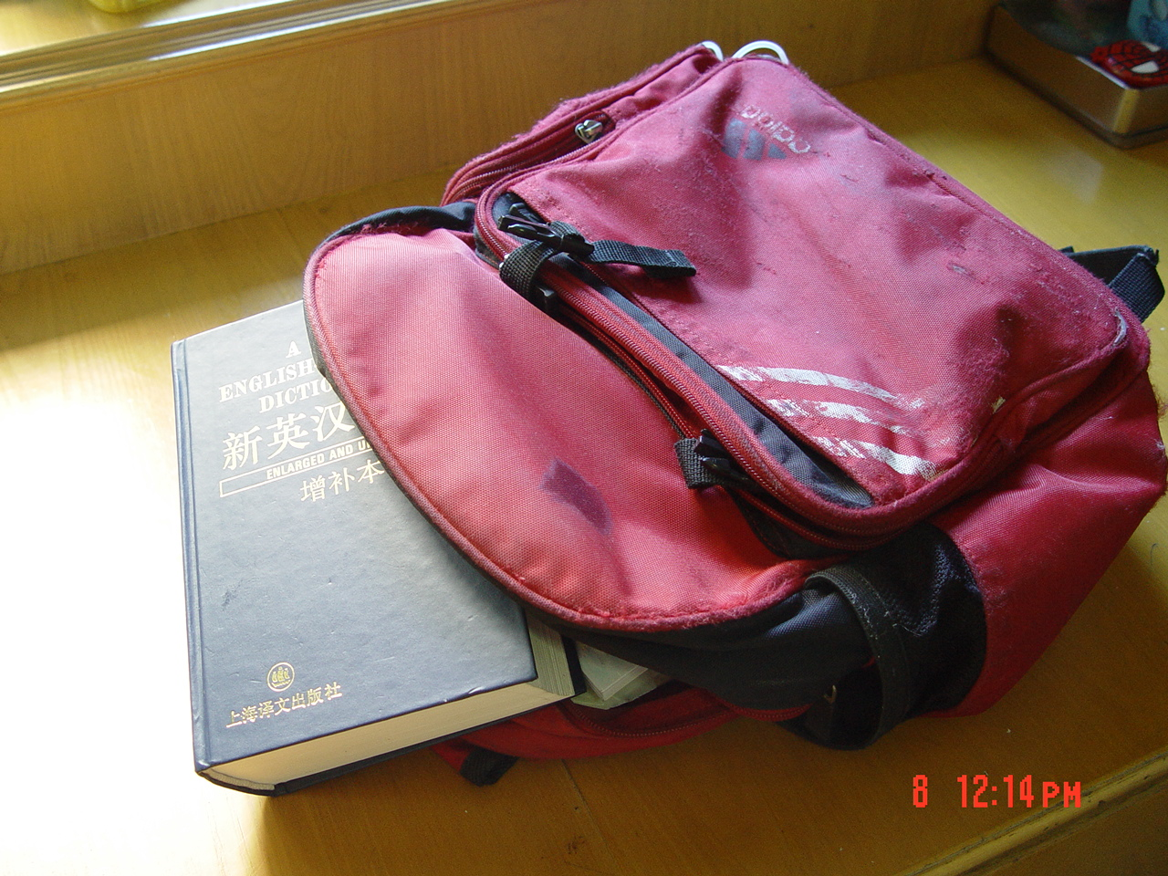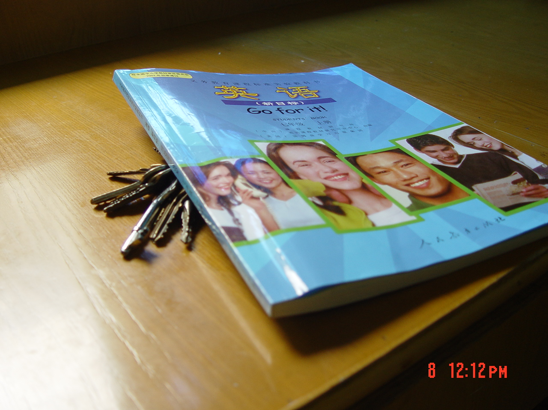

A: Where is …..
B: It’s…..
A: What’s ….
B: There is /are….
A: ……
- 就近原则练习
用are，is填空
1. There ______ three pencils and a pen in my pencil-box.
2. There ______ many kites(风筝) in the sky.
3. There ______ an eraser and two rulers on your desk.
4. What ______ in your schoolbag.
5. There ______ a pencil-box in my schoolbag.

Step 2:观看图片，利用多媒体形象教习球类，及球拍的单词。
Basketball, soccer ball, volleyball, tennis, ping pong ball, baseball, tennis racket, ping pong bat, baseball bat

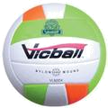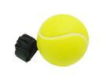

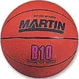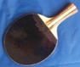
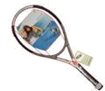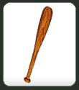
  - Introduce the key vocabulary: Show the things in the picture and describe them.
Model: What’s this? A soccer ball. This is my volleyball. I have a volleyball. A volleyball.
  - Repeat the key vocabulary: Repeat the new words for the students to remember by asking “What’s ____?”.
  - Show the picture in 1a for the students to match.
  - Check the answers as the class.

Step 3:
Task One: Do pairwork as :—Do you have a(basketball, volleyball…) —Yes, I do./no, I don’t.
Task Two: Do pairwork as :—Dose he have a(basketball, volleyball…) —Yes, he dose./No, he doesn’t.
Task Three：with these sentences
（1）“This is my soccer. I have a soccer ball. Do I have a soccer ball? Yes, I do.”
（2）“This is David’s volleyball. He has a volleyball. Does he have a volleyball? Yes, he does. ”
Task Four: 学习第一，二，三人称，及其对应的单复数
1. I have no money. ———— She has no money.
2. I have no necklace. ———— She has no necklace.
3. I have no credit card. ———— She has no credit card.

Step4 Listening
- 1b
Task one: listen and circle the words you hear.
Task Two: Check the answers.
Task three: Listen again and write down their own. Sports he or she likes.
- 2a
Task One: listen for the names in the pictures, and number the pictures [1-4] Play the recording a second time. This time students number the pictures.
Task Two: listen again. Match the people from activity 2a to the balls in the picture.
Task Three: Correct the answers.
Task Four: Show the tapescripts. Let’s students read and repeat.

Step 5:Grammar focus
Review the grammar box. Point out the contractions do and does, don’t and doesn’t. Repeat after the teacher.

Step 6: Relax and watch Flash with basketball..

Step 6:Homework
Tell students to interview their classmates or their friends using Do you have…? / Does he/she have…?

第二课时
Step One Revision
Review ：1.球类，及球拍有关的单词。
Basketball, soccer ball, volleyball, tennis, ping pong ball, baseball, tennis racket, ping pong bat, baseball bat

- Play a game:
“ Who has the best memory?”
A: I have a soccer ball
B: She has a soccer ball, and I have a volleyball.
C: She has a soccer ball, and he has a volleyball, and I have a tennis racket.
D: She has a soccer ball, and he has a volleyball, and he has a tennis racket, and I have a ping-pong ball.

Step Two: Presentation:
T: teacher S: student
1. T: What’s your favourite ball game?
S: My favourite ball game is…
T: Do you want to join the school sports club?
( Show the poster of P27/ 4)
If you want to ,please fill in the blank.
2.Ask the students to do it . Then introduce yourself.

Step Three : Drills
根据学生所填信息, 结合我所提供的图片,引出句型和形容词:
A: Let’s play soccer.
B: I don’t have a soccer ball.
A: Well, let’s play volleyball. 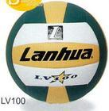
B: That sounds good/ interesting/fun/boring/difficult/relaxing
Ask them to work in pairs.

Step Four: pairwork
Do 3a: Task One . Ask the students to fill in the blanks with the words from the box.
Task Two. Act it out.
Do 3b: Task One . Work in pairs.
Task Two. Ask them to act out their own dialogue.

Step Five: listening practice.
Task 1. Do Section B . 1a Match the words with the picture.
Task 2.Listen and check the words that you hear in 1a.
Task3.Listen again .Write down a word to describe the activities .

Step Six: Do some exercises:
- 短文改错: 读下面的对话,判断每行是否有错,如有错,请找出并改正.
A: Excuse me, Li Ping. Do you have a soccer ball?
B: Sorry, I do.
A: Do you think Lin Tao have one?
B: Yes, I think so. You can ask for him.
A: Lin Tao, can I borrow you soccer ball please?
B: Of course you can! ?
A: Thank you. Let play soccer.
B: Well, that’s sounds boring.
A: Then let’s play the tennis. I have tennis rackets and balls.
B: Oh! That sounds exciteing.

Step Seven : Homework:
Write a passage to tell sth about your first name, last name your class,the sports you like and why.

第三课时
Step One : Revision
Ask the students to report the passage he or she write.
Then ask some students to answer the questions about the passage.

Step Two: Presentation
1.问学生既然你喜欢运动,那么你家里分别有多少有关的球类?
2.Then tell the students :
T: We will listen to a passage .Please listen and try to answer these questions.
- Who has a great sports collection?
- How many tennis rackets does he have?
- How many tennis rackets, basketballs, and baseballs does he have?
- How many soccer balls and volleyballs does he have?
- Does he play sports ?
- What does he do?
S: (answer the questions)
3. Ask the students to retell according to the information.
4. Come to SectionB /3a
1. Listen and repeat after the tape .
2. Go through and expiain some important words ,phrases and sentences:
Has a great sports collection.
He doesn’t play sports-------he only watches them on TV.
He has 8 tennis rackets

Step Three: Practice
1.Ask the students to do this exercise.
2.Check the answers.

Step Four: Self Check
Task One; Check the words you know.
Task Two: Write numbers in the boxes to make the conversation. Then read the dialogue.
Task Four: Just for fun!

Step Five : Homework:
Write a passage about your uncle or aunt like SectionB/3a.

宁波华茂外国语学校
陈 敏 汪 静

