广州市2006年初中毕业生学业考试
英语
第一部分（共100分）
一、听力（共20题，30分）
听取信息（共5小题，5分，每题1分）
1．听下面一段对话，请根据题目要求，从所听到的内容中获取必要的信息，填入答题卡号为A～E的空格中，听对话前，你有10秒钟的时间阅读题目：对话读两遍。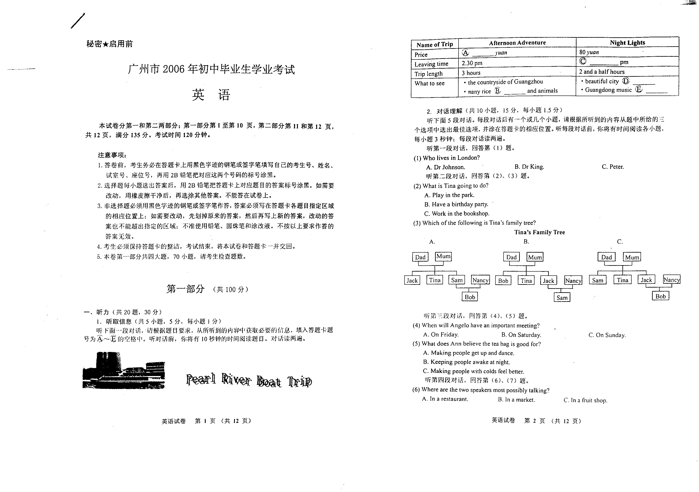
Name of Trip | Afternoon Adventure | Night Lights
Price | ________yuan | 80 yuan
Leaving Time | 2.30 pm | ________pm
Trip Length | 3 hours | 2 and a half hours
What to see |  the countryside of Guangzhou   many rice ______and animals |  beautiful city ________   Guangdong music ______
2．对话理解（共10小题，15分，每小题1.5分）
听下面5段对话，每段对话后有一个或几个小题，请根据所听到的内容从题中所给的三个选项中选出最佳选项，并涂在答题卡的相应位置。听每段对话前，你将有时间阅读各小题，每小题3秒钟：每段对话读两遍。
听第一段对话，回答第1题。
1. Who lives in London?
A. Dr Johnson. B. Dr King. C. Peter.
听第二段对话，回答第2、3题。
2. What is Tina going to do?
A. Play in the park. B. Have a birthday party. C. Work in the bookshop.
3. Which of the following is Tina’s family tree?
听第三段对话，回答第4、5题。
4. When will Angelo have an important meeting?
A. On Friday. B. On Saturday. C. On Sunday.
5. What does Ann believe the tea bag is good for?
A. Making people get up and dance. B. Keeping people awake at night.
C. Making people with colds feel better.
听第四段对话，回答第6、7题。
6. Where are the two speakers most possibly talking?
A. In a restaurant. B. In a market. C. In a fruit shop.
7. What fruit does the man finally ask for?
A. A pair of bananas. B. Two pears and a banana. C. A pear and two bananas.
听第五段对话，回答第8至10题。
8. Where is the doctor’s office?
A. No. 45 Smith Street. B. No. 51 West Street. C. No. 51 Smith Street.
9. When will John go to see the doctor?
A. Today. B. Tomorrow. C. Friday.
10. How will John go to the doctor’s office?
A. By bus. B. By taxi. C. On foot.
3、讲话理解（共5小题，10分，每小题2分）
听下面一段讲话。讲话后有5个小题，请根据所听到的内容从题中所给的三个选项中选出最佳选项，并涂在答题卡的相应位置。听讲话前，你将有时间阅读各小题，每小题5秒钟：
讲话读两遍。
11. What is the talk about?
A. The history of the Sydney Bridge. B. When to climb the Sydney Bridge.
C. Preparing to climb the Sydney Bridge.
12. Why must the climbers wear special black jackets?
A. To show they’re in the same climbing group.
B. To keep warm at the top of the bridge.
C. To hold their phones and keys.
13. What is the special radio used for?
A. Talking to the people 134 metres below. B. Listening to the introduction of the bridge.
C. Talking to the guide on the bridge.
14. How long will the group spend on the bridge?
A. Half an hour. B. One and a half hours. C. Two hours.
15. What can we learn from the talk?
A. The weather doesn’t change at the top of the bridge.
B. The bridge has a long and interesting history.
C. Safety is very important when climbing the bridge.
二、语言知识与运用 （共20小题，20分，每题1分）
在下列各题的四个选项中选出一个最佳答案。
16. ---Hello. May I speak to Mrs White?
---Sorry. She is out right now. Can I ______ a message?
A. carry B. take C. leave D. give
17. If you don’t _______me by two o’clock today, it means I won’t be coming.
A. hear B. hear of C. hear from D. hear about
18. ---How much did this CD _______ you, Sally?
---I got it for 5 dollars.
A. use B. spend C. take D. cost
19. Sue got up very late this morning and that was ______she was late for school.
A. why B. what C. where D. whether

20. ---Would you mind _______me a sweater? I feel a little cold.
---Of course not. I’ll go and get it right now.
A. to get B. get C. getting D. will get
21. I’ve had ______bad headache all day, so I think I’ll go to _______bed early.
A. a; 不填 B. 不填; the C. 不填 ; 不填 D. a; the
22. ---Could you lend me your dictionary? I left _______ at home.
---Certainly.
A. it B. yours C. one D. mine
23. My aunt will arrive in Guangzhou _______the morning of July 15.
A. at B. on C. in D. till
24. As usual, Meihua _______at 6:30 this morning by her mother to get ready for school.
A. has woken up B. woke up C. wakes up D. was woken up
25. The bus _______ suddenly when a group of students ran onto the road.
A. stops B. stopped C. has stopped D. is stopping
26. My uncle used _______ a very good football player, but this was a long time ago.
A. to being B. being C. be D. to be
27. ---My car has broken down. Could you please give me a ride tomorrow?
---I’m sorry I ________. I’m leaving for London tonight.
A. can’t B. mustn’t C. couldn’t D. shouldn’t
28. ---Is _______true that Americans eat hamburgers and hot dogs every day?
---No, that’s not true, but they are both very popular foods in America.
A. this B. anything C. it D. something
29. ---I _______to get to the South Mall. Could you tell me which bus I should take?
---Just catch the No. 10 bus from here. It’s the 4th stop.
A. am trying B. would try C. tried D. have tried
30. ---How well did you do in the maths exam?
---Better than before. I think it was _______ difficult than the last one.
A. more B. less C. much D. very
31. ______Mrs Wilson came into the classroom, all the children welcomed her.
A. Whether B. As well as C. If D. As soon as
32. Liz is kind to others and she has always found it easy to _______ at school.
A. make friend B. make friend with C. make friends D. make friends with
33. _______weather we had on our holiday!
A. What a good B. How a good C. What good D. How good
34. We didn’t have enough chairs, _______some of the students had to sit on the floor.
A. but B. so C. or D. and
35. There was a fire in the street last night, but the firemen _______within twenty minutes.
A. took it out B. brought it out C. worked it out D. put it out
三、完形填空（共10小题，10分，每小题1分）
先通读下面短文，掌握大意，然后从每题的四个选项中选择可以相应空白处的最佳答案。
I have always been interested in clowns (小丑). The earliest thing I can remember, as a child of three, is seeing a pair of clowns ---one very fat, and the other very 36_. A traveling circus (马戏团) came to our town and my parents took me to see it. When we arrived at the circus, everyone was laughing at the clowns. I didn’t understand why they were laughing, _37 I laughed too.
While I was 38_, the fat clown came and sat down next to me. “Shall we dance?” he asked, then _39 me up and began dancing. I felt frightened and began to cry. _40 then I have been interested in clowns. They make me laugh a lot, although they still make me a bit 41 too.
In life, we sometimes laugh at things that 42 us. We often laugh most at people who make us nervous. When we laugh, we relax and 43 ourselves. People who never laugh can become worried and ill. Laughter is like medicine and a clown is like a 44_.
There have always been, and there will always be clowns, because people need to laugh. Laughter is the best kind of 45 in life.
36. | A. happy | B. thin | C. kind | D. lucky
37. | A. and | B. so | C. or | D. but
38. | A. dancing | B. eating | C. laughing | D. crying
39. | A. picked | B. threw | C. hung | D. pushed
40. | A. Before | B. Since | C. By | D. From
41. | A. tired | B. silly | C. afraid | D. sick
42. | A. trouble | B. surprise | C. interest | D. frighten
43. | A. play | B. love | C. enjoy | D. understand
44. | A. doctor | B. nurse | C. friend | D. teacher
45. | A. dream | B. medicine | C. care | D. color
四、阅读理解（共20小题，40分，每小题2分）
阅读下面5篇短文，然后根据短文内容选择最佳答案。
A
It was a great day for a picnic and a picnic was a great day to start the summer holiday. Fred brought his classmates John and Betty to a wonderful picnic place.
After lunch, John said they should play football. When the ball came to Fred, he locked it into some long grass. “I’ll get it.” he said and hurried off to find the ball. Moments later there was a shout and out came Fred holding his leg, “I’ve bitten by a snake!”
As the others rushed over to help. Fred began laughing. “Ha! I’m not really hurt.” But Betty didn’t laugh, “I can’t believe you did that, Fred. I was really frightened for you.”
The friends then decided to go for a swim. John and Betty jumped into the water. Fred was standing on a long rock by the riverbank and said, “Watch me jump.” They shouted excitedly as he went under the water, but as the seconds passed he didn’t come back to the top. The friends became worried. Suddenly they heard Fred’s laugh, “Won’t you ever learn? I swam behind this tree when I jumped.”
“Very funny, Fred?” said John angrily. “Anyway, I’m feeling tired and I’m going for a sleep.” Betty joined him.
Fred, however, moved to a narrow part of the river and jumped in. Although he was a good swimmer, the water there was moving much faster and Fred found himself dragged away. He managed to catch hold of a tree, but he was very tired now and with the water still moving very fast, couldn’t pull himself out.
Back at the picnic place, as Betty and John were preparing to sleep, they heard Fred’s cries for help, John looked at Betty and said, “Does he really think we’re so foolish? Wake me up in an hour. It’ll be time to go back home then.”
46. What happened when Fred went to get the football?
A. He was bitten by a snake. B. He fell and cut himself.
C. He called for the others to help him. D. He let out a frightening shout.
47. At the end of the story, why didn’t John and Betty go to help Fred?
A. They didn’t believe that Fred was really in trouble.
B. They thought Fred was a good swimmer.
C. They couldn’t hear his cries for help.
D. They were too tired and needed to rest.
48. The underlined word “dragged” means “_______”.
A. pulled B. held C. guided D. gave
49. What can you learn from this story?
A. It is important for a person to tell the truth.
B. You should know how to swim if toy want to play in the river.
C. You must watch out for snakes in the countryside.
D. Picnics can often be dangerous for children.
B
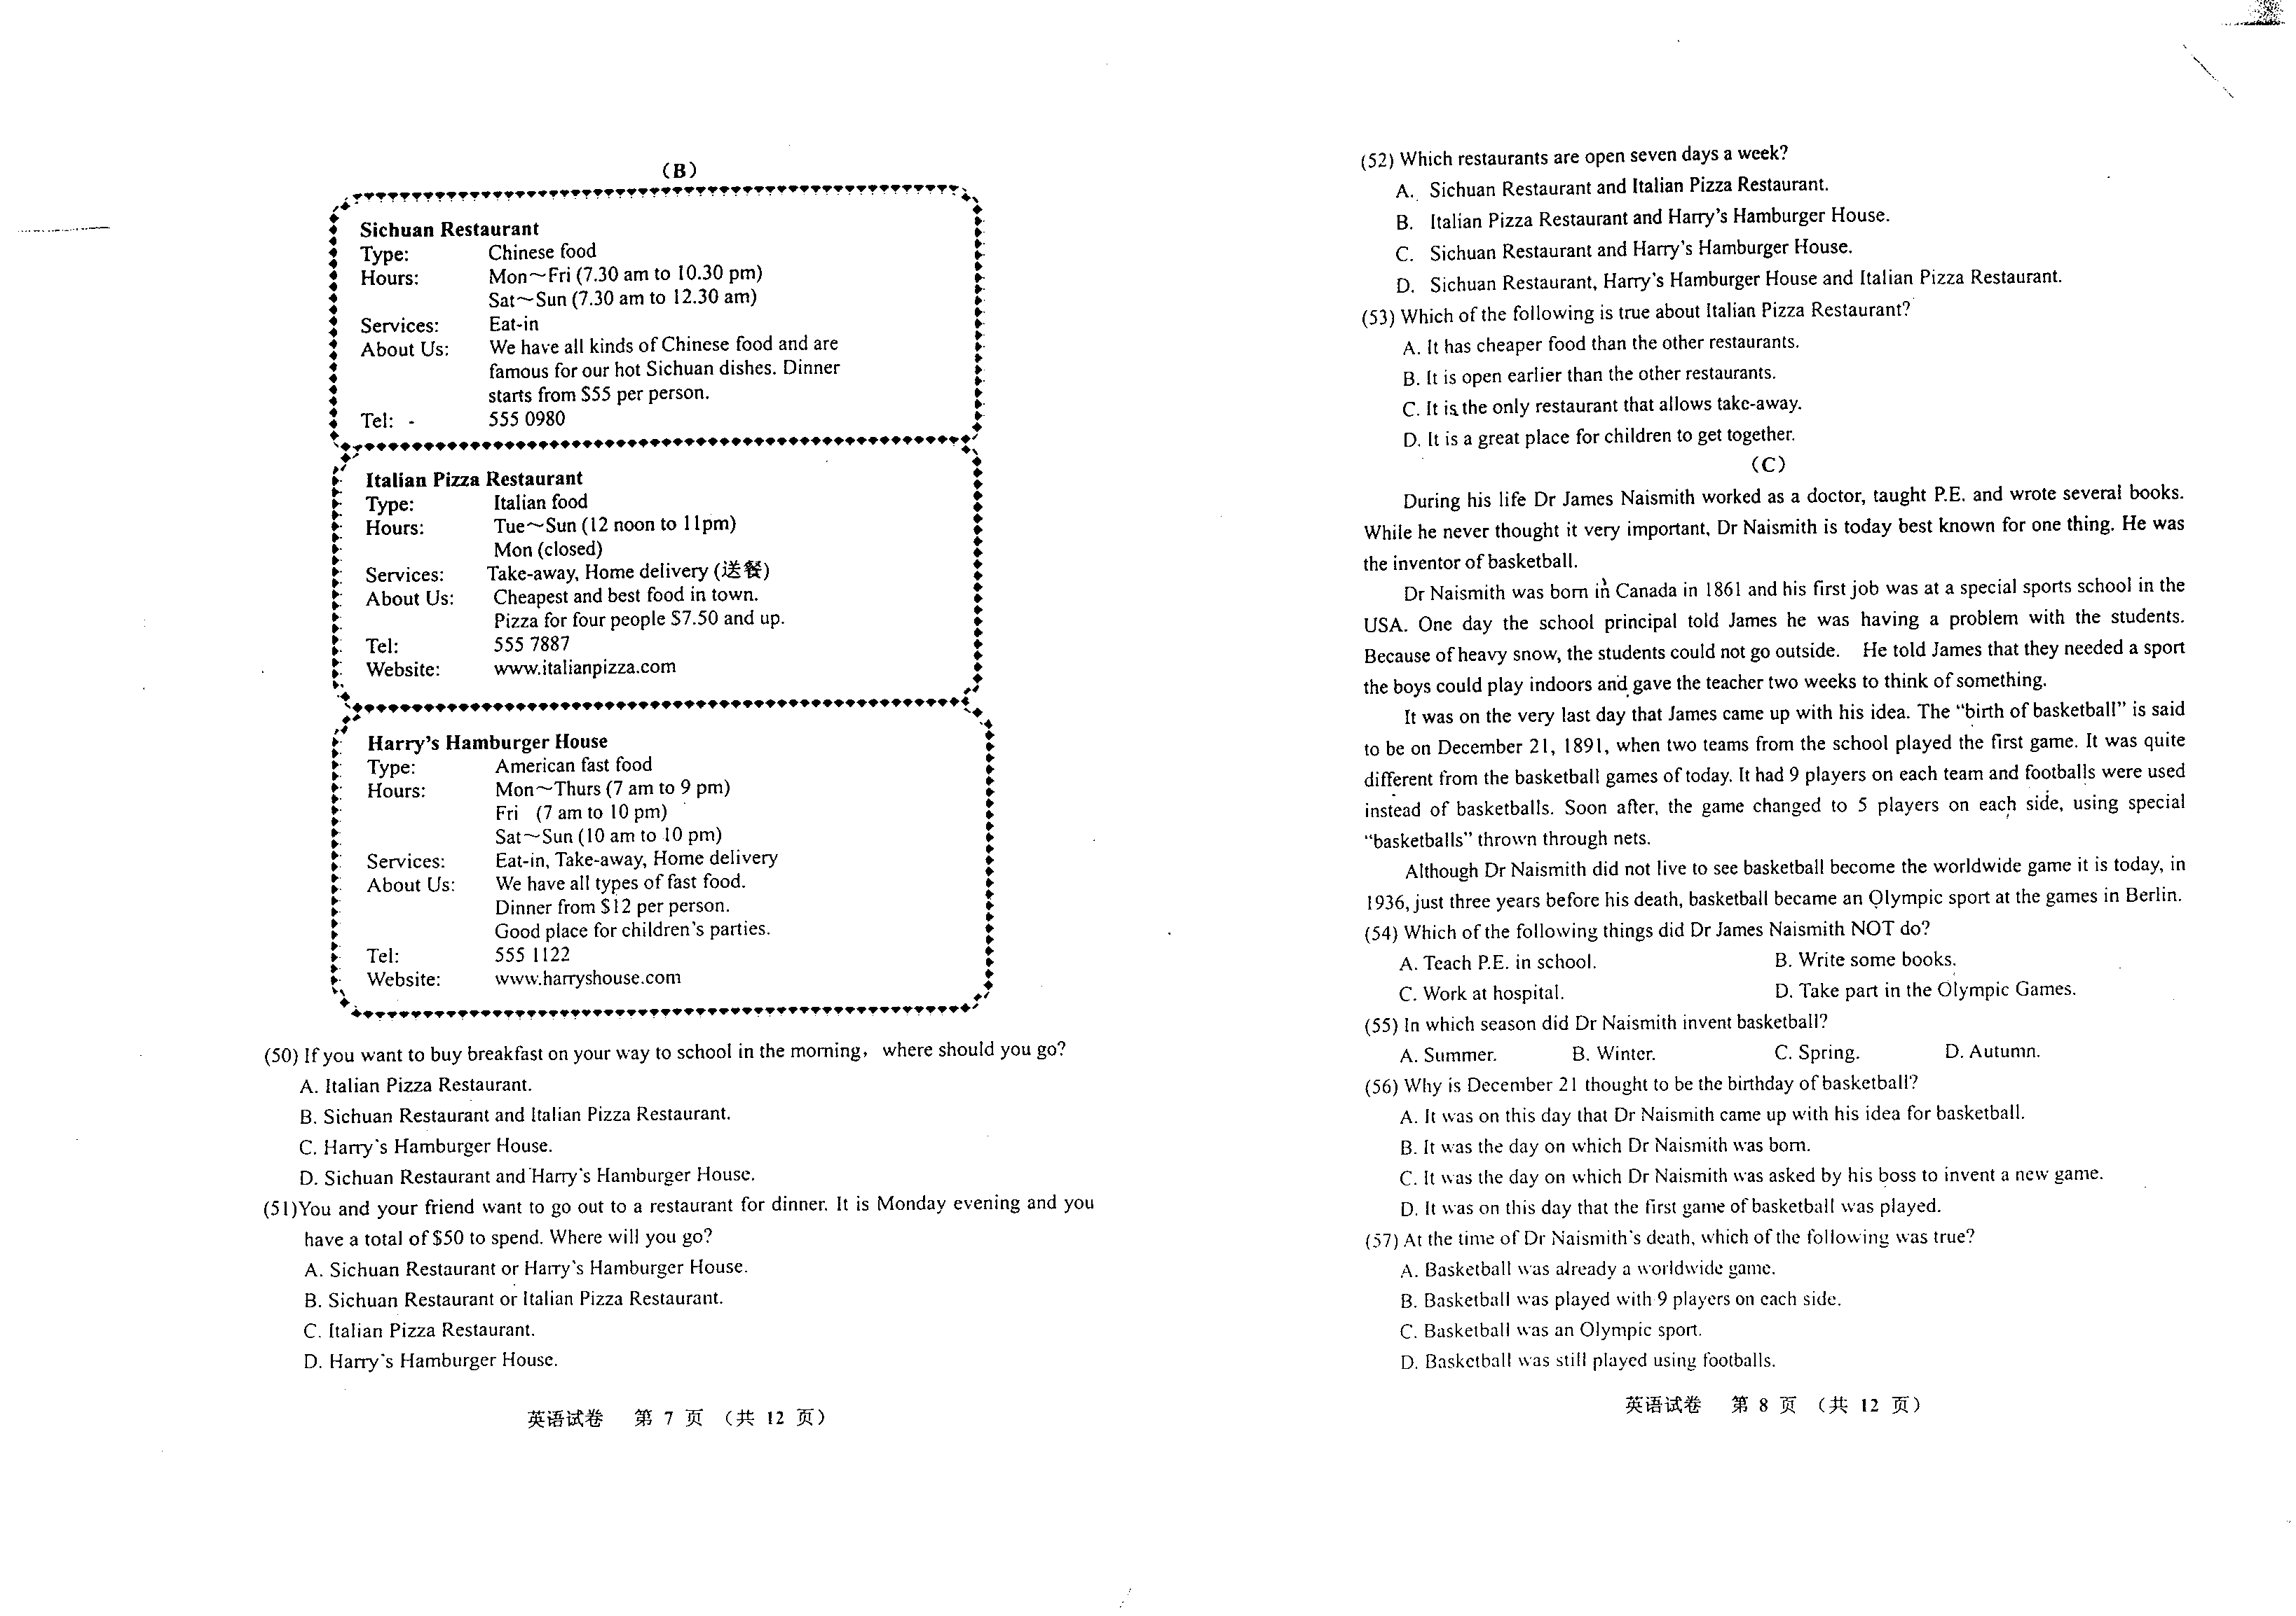
50. If you want to buy breakfast on your way to school in the morning, where should you go?
A. Italian Pizza Restaurant. B. Sichuan Restaurant and Italian Pizza Restaurant.
C. Harry’s Hamburger House. D. Sichuan Restaurant and Harry’s Hamburger House.
51. You and your friend want to go out to a restaurant for dinner. It is Monday evening and you have a total of ＄50 to spend. Where will you go?
A. Sichuan Restaurant or Harry’s Hamburger House.
B. Sichuan Restaurant or Italian Pizza Restaurant.
C. Italian Pizza Restaurant.
D. Harry’s Hamburger House.
52. Which restaurants are open seven days a week?
A. Sichuan Restaurant and Italian Pizza Restaurant.
B. Italian Pizza Restaurant and Harry’s Hamburger House.
C. Sichuan Restaurant and Harry’s Hamburger House.
D. Sichuan Restaurant, Harry’s Hamburger House and Italian Pizza Restaurant.
53. Which of the following is true about Italian Pizza Restaurant?
A. It has cheaper food than the other restaurants.
B. It is open earlier than the other restaurants.
C. It is the only restaurant that allows take-away.
D. It is a great place for children to get together.
C
During his life Dr James Naismith worked as a doctor, taught P.E and wrote several books. While he never thought it very important, Dr Naismith is today best known for one thing. He was the inventor of basketball.
Dr James Naismith was born in Canada in 1861 and his first job was at a special sports school in the USA. One day the school principal told James he was having a problem with the students. Because of heavy snow, the students could not go outside. He told James that they needed a sport the boys could play indoors and gave the teacher two weeks to think of something.
It was on the very last day that James came up with his idea. The “birth of basketball” is said to be on December 21, 1891, when two teams from the school played the first game. It was quite different from the basketball games of today. It had 9 players on each team and footballs were used instead of basketballs. Soon after, the game changed to 5 players on each side, using special “basketballs” through nets.
Although Dr Naismith did not live to see basketball become the worldwide game it is today, in 1936, just three years before his death, basketball became an Olympic sport at the games in Berlin.
54. Which of the following things did Dr James Naismith NOT do?
A. Teach P.E in school. B. Write some books.
C. Work at hospital. D. Take part in the Olympic Games.
55. In which season did Dr Naismith invent basketball?
A. Summer. B. Winter. C. Spring. D. Autumn.
56. Why is December 21 thought to be the birthday of basketball?
A. It was on this day that Dr Naismith came up with his idea for basketball.
B. It was the day on which Dr Naismith was born.
C. It was the day on which Dr Naismith was asked by his boss to invent a new game.
D. It was on this day that the first game of basketball was played.
57. At the time of Dr Naismith’s death, which of the following was true?
A. Basketball was already a worldwide game.
B. Basketball was played with 9 players on each side.
C. Basketball was an Olympic sport.
D. Basketball was still played using footballs.
58. What would be the best title for this story?
A. History of Basketball B. How Basketball Has Changed
C. Father of Basketball D. Happy Birthday, Basketball
D
We have always been interested in the moon. 2000 years ago people already knew it moved around the earth and where it would be in the sky at different times of the year. At that time, everything about the moon was learned by watching it carefully in the sky.
When scientists could use telescopes to study the moon more closely, their ideas began to change. They could see the moon was made of rocks. Most scientists thought moon rocks would be different from those on Earth. This was because they believed the moon had once been a planet that had been caught in the earth’s gravity (引力) millions of years earlier.
In 1969 moon rocks were finally brought to the earth and studied. Much to their surprise, scientists found that, except for water, the moon and the earth were made of the same things. Once again new ideas were needed for this new information.
After years of study, most scientists now think that the moon was once part of Earth. They believe very early in its history, maybe 4 million years ago, something about the size of Mars hit Earth. This sent billions of rocks into space around our planet. These rocks slowly joined together and after many years became the moon.
In the future, even though our ideas about the moon may change again, we will still be interested in it.
59. What does the writer want to tell us in the passage?
A. Why people are interested in the moon.
B. How ideas about the moon have changed over time.
C. Where the moon came from in the past.
D. That people have finally learned the truth about the moon.
60. Before 1969 most scientists thought the moon was ________.
A. part of the earth billions of years earlier B. older than the earth
C. a planet caught by the earth’s gravity D. made of the same things as the earth
61. From this passage we can learn that ________.
A. scientists in the past were not clever B. the earth was once part of the moon
C. new information brings new ideas D. we now know everything about the moon
E
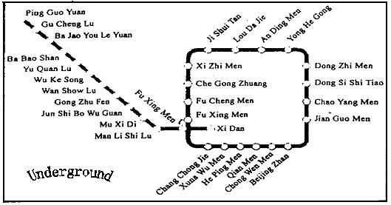
It is said that as the population of a city grows, so do its problems. Pollution, too many cars, and crowded streets are just a few of these difficulties. One way to help with these problems is city trains. Trains traveling to different parts of a city mean fewer cars and buses on our roads, cleaner air, and more open streets. In recent years, cities such as Guangzhou, Shenzhen and Shanghai have all built city train lines.
The first city train line in China was built in Beijing. The oldest part of the train line, from Beijing Zhan to Ping Guo Yuan was opened in 1969. Its length was 23.6 kilometres. As the city grew after 1980, so did the need for more trains. A newer train line was built to help move people around the city centre. The 16-kilometre-long “circle (环形) line” was finished in 1987. Since that time even more train stations have been built and today the train lines in the city are over 50 kilometres long.
For the 2008 Olympic Games, the trains of Beijing will be very important. It is thought that most of the people who go to watch the different sports during the Games will travel using trains.
62. The passage tells us about ________.
A. the problems in big cities B. city trains
C. the history of Beijing D. 2008 Olympic Games
63. How long was the first train line in Beijing?
A. About 16 kms. B. About 23 kms. C. About 33 kms. D. About 50 kms.
64. In 1977, which of the following places in Beijing could you go to by train?
A. Chao Yang Men. B. An Ding Men. C. Che Gong Zhuang. D. He Ping Men.
65. Which of the following is true?
A. In 2008, the Beijing train line will be nearly 40 years old.
B. The larger population a city has, the fewer problems it faces.
C. More and more cities are building undergrounds for the 2008 Olympic Games.
D. There are 20 stations on the “circle line” in Beijing.
第二部分（共35分）
五、句型变换（共5小题，10分，每小题2分）
根据各个句子的要求变换句型，在填写答题卡时，只要求写出空格部分的内容。
1. She said to me, “Don’t write the letter with a pencil.” (改为间接引语)
She told me __________with a pencil.
2. We should water the young trees every two days. (改为被动语态)
The young trees _____________ every two days.
3. They haven’t decided where to build the new hospital. (改为同一意思的复合句)
They haven’t decided _________________________the new hospital.
4. Tom is very pleased with the painting. Kate is very pleased with the painting, too. (合并为同一意思的简单句)
______Tom _______ Kate are very pleased with the painting.
5. The boy in white is Sue’s child. (就划线部分提问)
____________________in white?
六、综合填空（共10格，10分，每格1分）
根据短文内容填入适当的单词，使短文的意思完整，每格限写一个单词，要求首字母与所给的字母相同，在填写答卷时，要求写出完整的单词。
David goes to school in New Zealand. When he was at primary school, he didn’t have any 6 h to do. He only had to read for 15 minutes very evening: that’s all! His school had a huge sports field that was 7 b enough for four football fields. He loved to run around with his 8 f . His teacher was nice, too. Sometimes she would say, “9 S your maths work please, children. It’s a beautiful day outside. Let’s go out and play a 10 g !”
Things have changed since David started high school. He still 11 p a lot of sports, but the work is a bit harder. He has to do some homework, but not too much, only one hour each night.
But the 12 b thing David loves about his high school is all the sports he can play. The sports ground has a running track, a 13 s pool and four football fields. David plays sports every day after school.
David is looking forward to 14 g to university. After he has finished his studies, he wants to 15 t around the world. He dreams and hopes that day he can.
七、书面表达（15分）
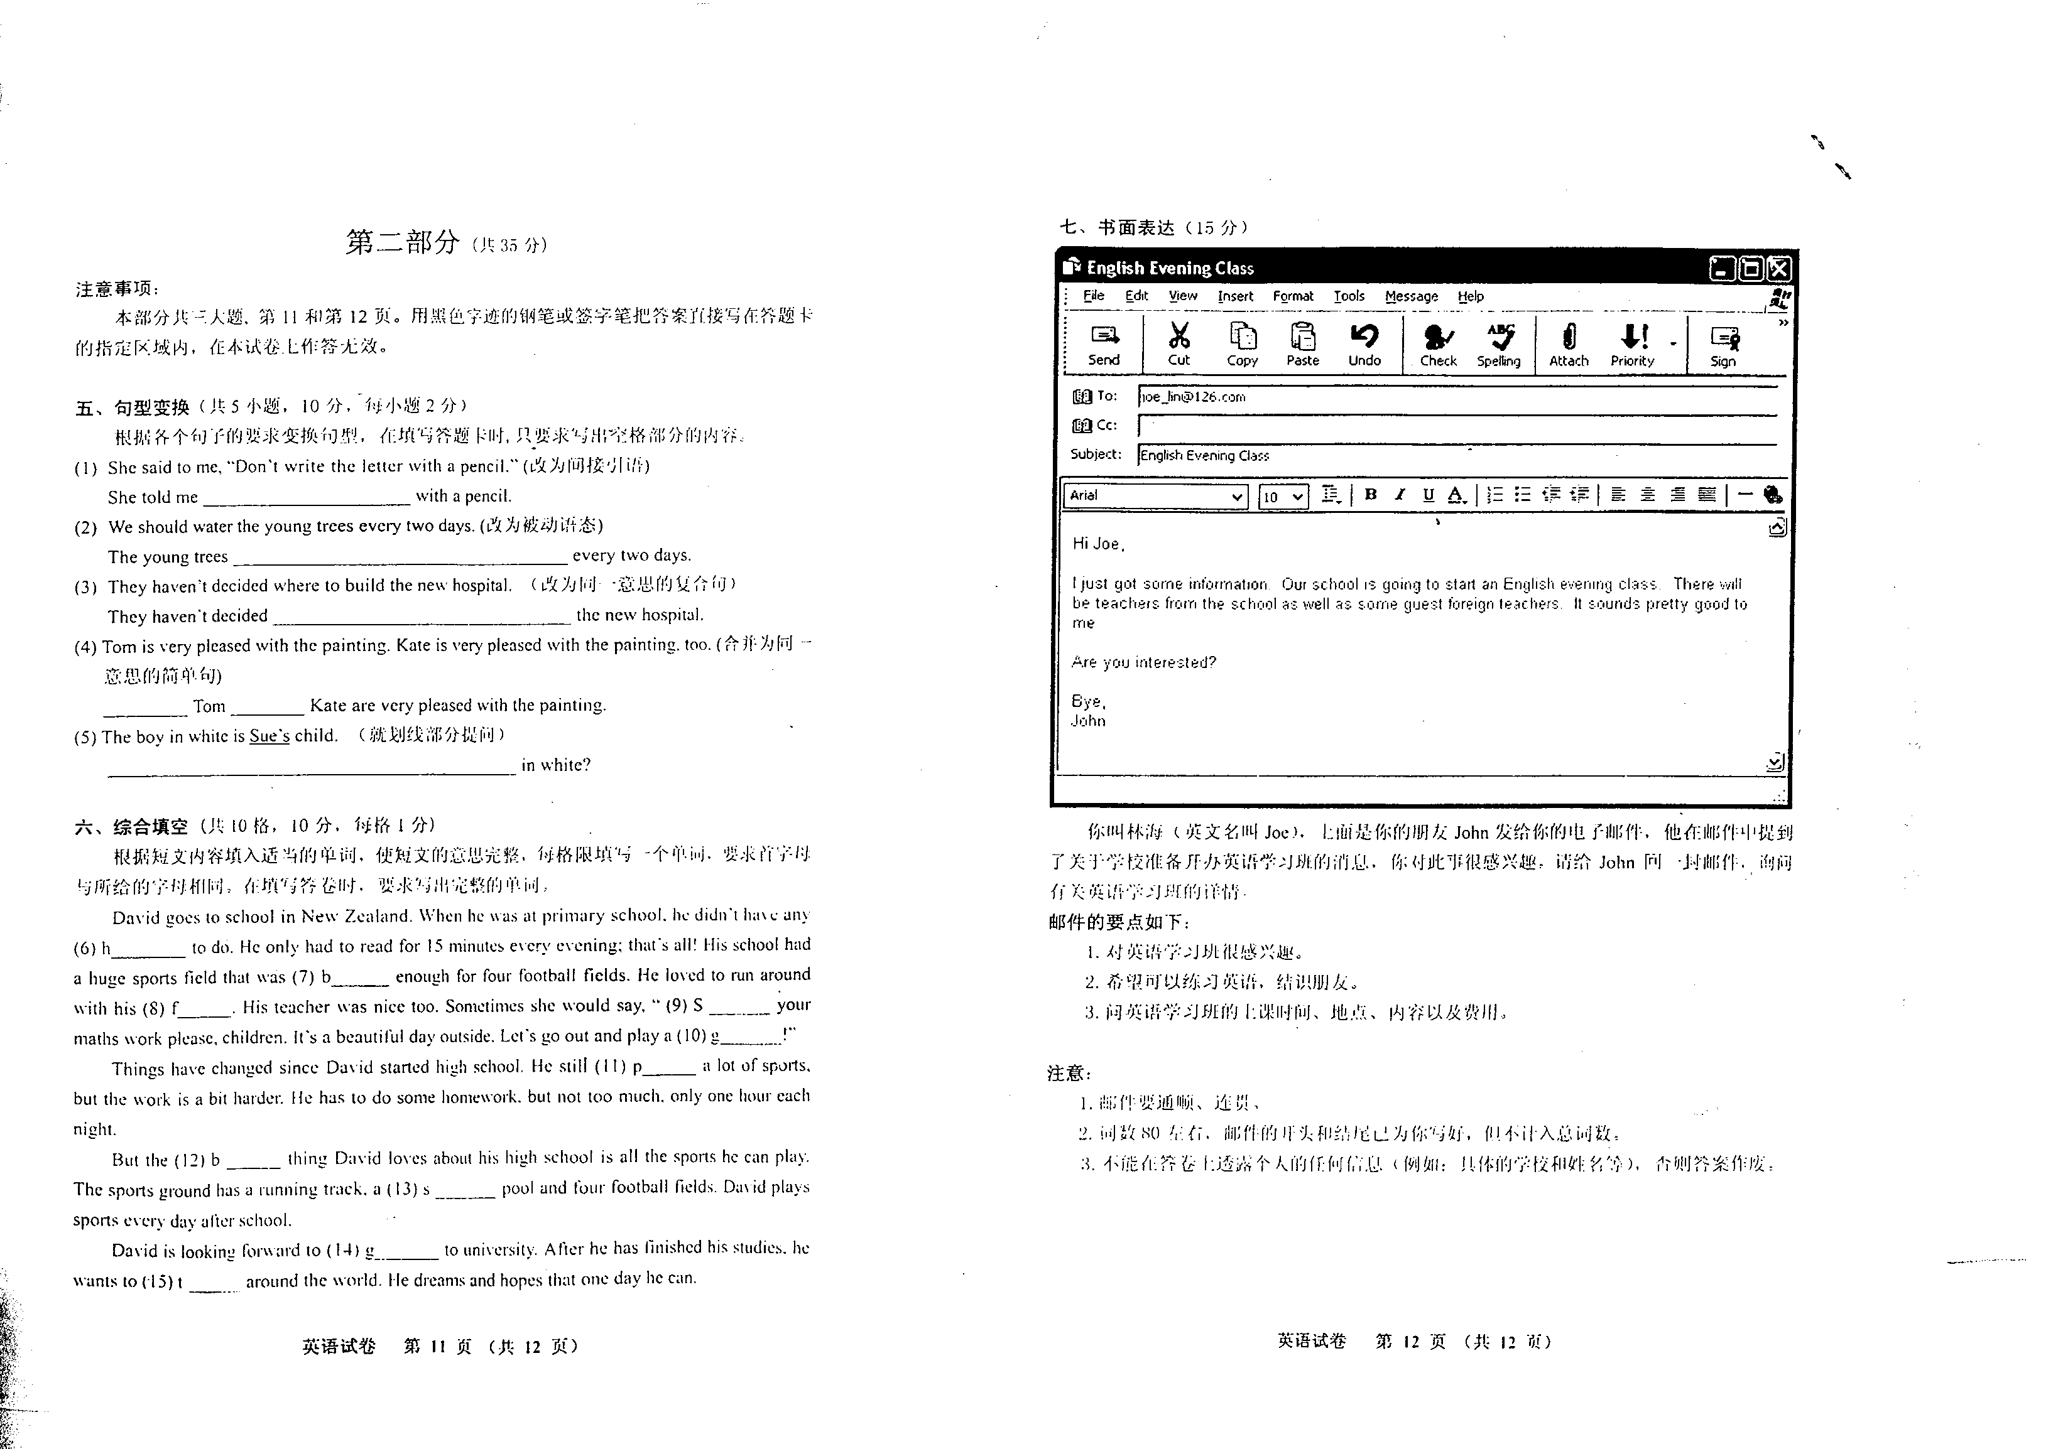
你叫林海（英文名叫Joe），上面是你的朋友John发给你的电子邮件，他在邮件中提到了关于学校准备开办英语学习班的消息，你对此事很感兴趣，请给John回一封邮件，询问有关英语学习班的详情。
邮件的要点如下：
1．对英语学习班很感兴趣。
2．希望可以练习英语，结识朋友。
3．问英语学习班的上课时间、地点、内容以及费用。
注意：
1．邮件要通顺、连贯。
2．词数80左右，邮件的开头和结尾已为你写好，但不计人总词数。
3．不能在答卷上透露个人的任何信息（例如具体的学校和姓名等），否则答案作废。

参考答案
一、听力（共30分）
1．听取信息（共5分，每小题1分）
(A) 45 (B) farms (C) 8:30 (D) lights (E) show
2．对话理解（共15分，每小题1.5分）
1. A 2. B 3. C 4. A 5. C 6. A 7. B 8. C
9. A 10. B
3．讲话理解（共10分，每小题2分）
11. C 12. A 13. B 14. C 15. C
二、语言知识与运用（共20分，每小题1分）
16---20. BCDAC 21---25. ADBDB 26---30. DACAB 31---35. DCCBD
三、完形填空（共10分，每小题1分）
36---40. BDCAB 41---45. CDCAB
四、阅读理解（共40分，每小题2分）
（A）46---49. DAAA （B）50---53. CDCA （C）54---58. DBDCC
（D）59---61. BCC （E）62---65. BBDA
第二部分
五、句型变换（共10分，每小题2分）
1. not to write the letter
2. should be watered by us
3. where they will/should build
4. Both, and
5. Whose child is the boy
六、综合填空（共10分，每格1分）
6. homework 7. big 8. friend(s) 9. Stop 10. game 11. plays 12. best
13. swimming 14. going 15. travel
七、书面表达（15分）
One of the possible versions:
Dear John,
Thanks very much for the information about the English evening class. It sounds very interesting to me. You know I want to practise my English and make some new friends. I think this English evening class will be helpful to me. Could you please tell me a little more about the class? When does it begin and hoe much does it cost? Where will the class be held? Also, do you have any more information about what we will do in class?
I’m looking forward to hearing from you as soon as possible.
Yours
Joe

