2009年中考英语真题分类汇编-补全句子&完成句子及表格阅读
知识点九，
2.完成句子及表格
（一）（2009江西）
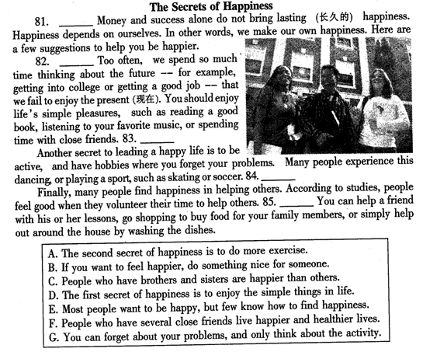
【答案】
（二）（2009娄底市）
阅读下面的短文，根据短文内容，完成表格。（每空填1至3个词）
China has decided to stop the use of free plastic bags. Supermarkets， shops and outlets(经销店) in China can’t offer plastic bags any more.
Every year， people use too many plastic bags. They throw them here and there after they have used them. The government has done its best to deal with them but failed. While we offer quick service（服务） to customers， the plastic bags pollute water，earth and air， and they waste the oil. The government asks people to go back to carry cloth bags and use baskets when they go to buy something. The cloth bags and the baskets can be used again and again.
Many months have passed. The environment has been improved a lot.
Action | Make a decision to stop the use of 41.
42. | Supermarkets， shops and outlets
Advantage | Offer 43. service to customers
Disadvantage | Pollute water， earth and air and waste 44.
What should we do | Go back to carry cloth bags and use 45.
【答案】
41. free plastic bags 42. Places 43. quick 44.the oil 45. baskets
（三）（2009宿迁）
阅读下列短文，根据短文内容填写表格（每空限填一词）。
One of the most well-known directors of our time is Stephen Spielberg. He was born in Cincinnati on 18 December 1946. His father was an electric engineer and his mother was a performing pianist. His sister, Anne Spielberg, became a screenwriter who wrote the stories for many famous films.
Stephen had always wanted to be a director ever since he was a young boy. When he was just 13 years old, he made a 40-minute film. It won a local competition. Three years later, he produced a film called Firelight, which made one hundred dollars’ profit at the cinema in his hometown. Many of the ideas from this film were later used for one of his most famous films called Close Encounters of the Third Kind.
When he was 18 years old, he wanted to go to film school so that he could improve his skills and become an even better director. Unluckily, he was unsuccessful in getting a place at this school so he went to a university in California to study English. Even though he had failed to get into the school he wanted to go to, he didn’t let this stop him following his dream to become a great director.
Stephen Spielberg has directed many films since his first major film in 1976. He now owns many different businesses, most of which are involved in the film industry.
Year | What happened
1946 | 76. Stephen Spielberg_________ ___________ in Cincinnati.
1959 | 77. Stephen Spielberg made a __________ film and it_________ a local competition.
1962 | 78. Stephen Spielberg produced a film called___________, from which many __________ were later used for Close Encounters of the Third Kind.
79. _______ | Though he_____________ to get into the film school he wanted to go to, Stephen Spielberg didn’t give up his dream to become a great director.
1976 | 80. Stephen Spielberg____________ his ___________ major film.
【答案】76. was born 77. 40-minute; won 78. Firelight; ideas 79. 1964; failed 80. directed/ made/ produced; first
（四）（2009新疆埠康市）
请分别为下面四则谚语及图片找到相应的寓意，并把序号A、B、C、D填在答题卷相应的位置。
1.It's never too late to learn.   | 2.A crane standing amidst a flock of chickens.   | 3. The early bird catches the worm.   | 4. Play a harp before a cow.   | 5. A book holds a house of gold.  

A. This proverb means that you do something useless.
B. This proverb means that someone is the best of all.
C. This proverb means that if you study hard, you will succeed.
D. This proverb means that there’re many things to learn no matter how old you are..
E. This proverb means that if you do something early or before others, you will have more chances and be successful.
1. 2. 3. 4. 5.
【答案】1. D 2. B 3. E 4. A 5. C
（五）（2009常州）
阅读下面短文，在表格内的空白处填入合适的答案(每格词数不限)
The Internet has changed our habits, including our habit of sending greeting cards. There are many e-card websites that make it so easy to find the right greeting cards. They have greatly changed the way we send greetings to each other.
Our lives have become so busy that we have limited personal time. These e-card websites have allowed everyone to easily share their feelings and emotions(感情) with the people they love. They contain(包括) plenty of greeting cards that can be used immediately. The users can choose any card they like, from festival greetings to birthday wishes. In fact, e-cards are perfect for any event. That’s why more and more people like to send e-cards. If the users are interested in making their own greeting cards on the internet, they can create a card within only a few minutes.
Another benefit(好处) of e-card websites is that they have made it possible for you to send top quality cards to your beloved (心爱的) ones and surprise them with cheerful greetings. They allow you to send your greetings on a specific(特定的) date. So you can plan for the occasion(场合)when you want to send the card. For example, you can send your e-card on a certain day and then visit the person with some flowers the next day. This will surely create a good impression(印象)on the person you love.
We have never forgotten the importance of saying sorry to our beloved ones. But sometimes we fail to do so because, we are not brave enough to face those we hurt. Some e- cards on these websites allow us to express our feelings in a more thoughtful way.
Although some people still would rather buy traditional cards in the shops for the persons they love, especially when they want the cards to last a long time, more and more people are choosing to send greetings on the Internet.
Title: Sending E-cards on the Internet
Introduction to the topic | The way we send greetings to each other 1 because of the e-card websites.
Reasons why more and more people are using e-cards | Plenty of greeting cards on the websites make it possible for people to 2 with others easily.  Users can choose or make their own e-cards, and it doesn’t take 3_____________time.  Users can plan for the occasion and help create a good impression on the persons they love.  E-cards can help you to say 4 to those you hurt in a thoughtful way.
Conclusion | E-cards are becoming more and more 5 .
【答案】1. has been greatly changed/is different from before/is changing
2. communicate/ share their feelings and emotions
3. a long/much/too much
4. sorry
5. popular/welcome/fashionable
（六）（2009辽宁锦州）
How to drink tea
All around the world，people drink tea．But tea does not mean the same thing to everyone．
In China，for example，tea is always served(招待)when people get together．The Chinese drink
it at any time of day at homes or in teahouse．They prefer their tea plain，with nothing else in it．
Tea is also important in Japan．The Japanese have a special(特别的)way of serving tea called a tea ceremony(仪式)．It is very old and full of meaning．Everything must be done in a special way in the ceremony．There is even a special room for it in Japanese homes．
Another tea—drinking country is England．In England，the late afternoon is ‘‘tea time”．Almost everyone has a cup of tea then．The English usually make tea in tea-port and drink it with cream and sugar．They also eat cakes，cookies and little sandwiches at teatime．
Different people have different ways of drinking tea．
【答案】81．How to drink tea 82．People 83．China、Japan、England 84．Tea does not mean the same thing to everyone 85．Japanese drinking
（七）（2009辽宁锦州）
How do you learn best?
This week we asked students at New Star High School about the best ways to learn more English. Many said they learnt by using English. Some students had more specific suggestions. Lillian Li, for example, said the best way to learn new words was by reading English magazines. She said that memorizing the words of pop songs also helped a little. When we asked about studying grammar, she said, “I never study grammar. It’s too boring.”
Wei Ming feels differently. He’s been learning English for six years and really loves it. He thinks studying grammar is a great way to learn a language. He also thinks that watching English movies isn’t a bad way because he can watch the actors say the words. Sometimes, however, he finds watching movies frustrating because the people speak too quickly.
Liu Chang said that joining the English club at school was the best way to improve her English. Students get lots of practice and they also have fun. She added that having conversations with friends was not helpful at all. “We get excited about something and then end up speaking in Chinese,” she said.
【答案】
（一）（2009广东）
阅读下面短文，完成信息卡：
Skin-diving is a new sport today. This sport takes you into a wonderful new world. It is like a visit to the moon. When you are under water, it is easy for you to climb big rocks, because you are no longer heavy.
Here, under water, everything is blue and green. During the day, there is plenty of light. When fish swim nearby, you can catch them with your hands.
When you have tanks of air on your back, you can stay in deep water for a long time. But you must be careful when you dive in deep water.
To catch fish is one of the most interesting parts of this sport. Besides, there are more uses for skin-diving. You can clean ships without taking them out of water. You can get many things from the deep sea.
Now you see that skin-diving is both useful and interesting.
In formation Card
A new sport today | 1.____________________
2._____________________ | There is plenty of light
Everything is 3_____________ | Under the water
You can stay in deep water for a long time with | 4.___________________________
One of the most interesting parts of this sport | 5.____________________
【答案】1.Skin-diving
2During the day
3.blue and green
4.Tanks of air on your back
5. To catch fish
（二）（2009绵羊）
阅读下面短文，然后根据短文内容补全文后表格中所缺失的信息，每空限填数字或一个单词。
My name is Jane. My job is to write stories and newsletters for a magazine. I love traveling and hope to visit Great Britain one day. I’d like a pen pal from London, who is interested in discussing the differences between Europe and Asia. I love listening to pop music and playing football.
I am Manuel. I’m a businessman and have a large company with many workers and clerks. I would like to find a pen pal who is also a businessman and lives in North America. I like using the Internet.
I am working in a university. I speak English, French and Russian. My family name is Jackson but my students usually call me Sarah. I’d like a pen pal who is interested in language learning working in Oxford University. I don’t like using computers for learning and I believe that true language learning can only happen in a classroom.
I am Peter and interested in the differences between East Europe and North America. I love riding my horse Jackie and listening to jazz. I usually get at 7 o’clock and go to school around 7:30 in the morning. I want to find a pen pal who has the same interest as me living in Sydney.
Cindy is my first name. I am working in a travel agency. Sometimes I am called Mr. Guide as I am working. I’d like to find a pen pal who comes from Europe. I like playing the piano and listening to jazz. I am interested in history, but I don’t like discussing languages.

First name | What to do | likes | Pen-pal from
Jane | 1__________ | Travelling, pop music, and playing football | London
Manuel | Businessman | Using 2.________________ | North America
3__________ | Teacher | Teaching | Oxford University
Peter | Student | Riding horse and listening to jazz | 4____________
Cindy | 5．_________ | Playing piano, listening to jazz history | Europe
【答案】1 reporter 2. Internet 3.Sarah 4. Sydney 5. Guide
（三）（2009湛江）
阅读下列短文，请根据题目要求，从短文内容中获取必要的信息，填在答题纸标号1-5的空格中。
There are some differences between British and American English. In grammar, for example, speakers of British English say “in hospital” and “Have you a pen?” Americans say “in the hospital” and “Do you have a pen?” Pronunciation is sometimes different. For example, when a learner is used to the British pronunciation [da:ns](dance), he may not understand the American pronunciation[dæns].There are differences between British and American English in spelling. For example, “travelled” and “honour” are British, “traveled” and “honor” are American. However, for the most part, British and American English are the same language.
(1) Between British and American English
------------- | British English | American English
In grammar | In (2) | In the hospital
In (3) | travelled | traveled
Besides, (4) is sometimes different.
However, British and American English are the (5) language.
【答案】1. Differences 2. hospital 3. spelling 4. pronunciation 5. same
3.其他
（一）（2009甘肃兰州）
Just as in face-to-face communication, there are some basic rules of behavior(行为) that should be followed on the Internet. The basic rule is simple: treat others in the same way you would want to be treated. ①Imagine how you’d feel if you were in the other person’s shoes.
For anything you’re about to send: ask yourself, “ Would I say that to the person’s face?” If the answer is no, rewrite and reread. If someone in the chat room is rude to you, you needn’t to fire back. You should either ignore(不理睬) the person, or use your chat software to block their messages. Remember to respect the beliefs and opinions of others in the chat room.
②Offer advice when asked by newcomers, as they may not be sure what to do or how to communicate. When someone makes a mistake, be kind about it. If you do decide to tell someone about the mistake, point it out politely. At the same time, if you find you are wrong, be sure to correct yourself and apologize to those that you have offended(冒犯).③询问别人诸如年龄、性别和家庭情况等隐私问题是不礼貌的。Unless you know the person very well, and you are both comfortable with sharing personal information, or don’t ask such questions.
1. In the chat room we must respect others’ ____________ and __________.
2. When you find you make a mistake in the chat room, what should you do?
____________________________________________________________________________
3.将划线部分①翻译成汉语
____________________________________________________________________________
4.选择一个适当的句子放在②处_______
A. First impressions last longest.
B. Everyone was new to the network once.
C. The internet has opened up a whole new world for us.
D. Even if you feel strongly about it, think twice before saying anything.
5.将划线部分③翻译成英语：
___________________________________________________________________________
【答案】1. beliefs, opinions
2. I should correct myself and apologize to those that I have offended.
3. 你要设身处地为别人着想。
4. B
5. It is impolite to task others personal questions such as their age, sex and families.
（二）（2009湖北宜昌）
Dear Miss Li,
I’d like tothankyouforsendingmon－eyto"AnimalHelpers",anorganizationsetuptohelpdisabledpeople.Forsureyouhavehelpedmakeitpossibleformetohave"Lucky",whohasfiledmylifewithplea－sure.
"Lucky"isaspecialytraineddogforthedisabled.Itisagoodnameforhimbe－causeIfeelveryluckytohavehim.Beingblind,deaf,unabletousemyhandseasilyarethechalengesIface."Lucky"helpsmeopenandshutthedoors,carrythingsandevenanswerthetelephone.Hecheersmeupalot.
I’lsendyouaphotoofhim ifyoulike,andIcouldshowyouhowhehelpsmetoooneday.AndIthankyouagainforsupporting"AnimalHelpers".Itisimportantthatthisorganizationdoesnotrunoutofmoney.Yourdonationisgreatlyappreciatedandthemoneyiswelusedtohelpdisabledpeoplelikeme. Bestwishes, LizSmith
71.LizSmithisa__________manwhois__________toseeorhear.
72."Lucky"isthe__________ofaspecialy__________dog.
73."AnimalHelpers"isanorganizationthatwas__________upto__________thedisabled.
74.LizSmithwil__________MissLiaphotoofthedogand__________herhow"Lucky"helpshim.
75.LizSmith wrotethisletterto__________MissLiforher__________toAnimalHelpers.
【答案】 71.disabled;unable
72.name;trained
73.set;help
74.send/give/show…;show
75.thank;donation/help
（三）（2009恩施州）
(1)Daniel was always making excuses for forgetting to do things. His usual excuse was: “ I was too busy.” or “I didn’t have time.”
Daniel’s parents were worried about him. “ He shouldn’t go through life making excuses all the time.” his father said. “ No one will trust him to do anything. He won’t be able to keep a job. No sensible(明智的)girl will marry him.”
(2)“I don’t know what we can do.” his mother said.
“I have an idea.” his father said. “If this doesn’t work, nothing will.”
The next day was Daniel’s birthday. He was really looking forward to getting exciting presents. He woke up, expecting his parents to wish him a happy birthday. But all day what they said was “Good morning, Daniel. Hurry, or you will be late for school.” There were no presents, not even a card. He was really disappointed.
“Never mind.” he thought. (3) “There’ll be a surprise for me after school.” But there wasn’t. Sadly he said to his parents at dinner, “Today’s my birthday.”
“Oh,” his father said. “So it is. I forgot.”
“So did I.” his mother said.
“How could you forget?” Daniel asked. “There must be a reason.”
“Well, yes.” his father said. “We have a really good excuse for forgetting your birthday, Daniel. We didn’t remember your birthday because we were too busy.”
Poor Daniel! He never had a silly excuse for not doing something again.
1. 请把句(1)译成汉语。______________________________________________。
2. 请把句(2)改成同义句。I don’t know what _________ _________.
3. 请把句(3)改成间接引语。
He thought _______________________________________________________.
4. Did Daniel get his birthday present at last?
__________________________.
5. What do you learn from the story?
_________________________________________________________________.
【答案】1. 丹尼尔(Daniel)总是为忘记做事而找借口。（大意符合即可）
2. to do
3. (that) there would be a surprise for him after school.
4. No, he didn’t.
5. It’s not good to make excuses for doing something wrong. / Don’t make any excuses. / Tell the truth. / Don’t lie to others.(答案不唯一, 观点符合文章大意。)
（四）（2009哈尔滨）
先阅读(A)、(B)两篇短文。然后根据题目要求及所给语境完成下列四项任务。
(A)
choose them easy communicate close
Are you the only child in your family?If SOy you are the most important person in your parents’hearts．They are the 66 people to you in the world．However，many teenagers like you have trouble 67 with their parents．They always complain(抱怨)that their parents say too much instead of listening to what they’re thinking．When they do something wrong，getting away from parents seems to be the only 68 ．In fact，what your parents do just shows love for you．They love you more than they love 69．Whenever you need help，they are always there，standing by you．Try to put yourself into their shoes，and you’11 understand them 70．
(B)
Co-operation(合作)is always needed when you make a project that the teacher gives you．
First，discuss all you would like to do with your classmates．Choose one of the members to write
down what!you’re talking about．Then，with the ideas you get，list all you want．Everyone shares tlle duty for the project．You can collect information not only from books but also on the Intemet．Making a sunrey(调查)and doing a research are also good ways．After that，all the members put what has been found together．Try to make the project more well—organized．In the end，you can give a report in front of your class to show the results of your hard work．
任务1：用方框中所给词的适当形式填空。使文章通顺，连贯。合理。(每空一词。每词限用一次)
66．________ 67．__________ 68．________ 69．_______ 7 0．_______
任务2：根据英文释义及首字母提示。拼写单词。
71.i_______plan；opinion
72.s_______use，pay or have something with others
任务3：同义旬转换。每空一词。
You can collect information not only from books but also on the Intemet．
You Can collect information 73_______from books 74__________on the Intemet．
任务4：根据短文内容简答问题。
What can you give in front of your class to show the results of your hard work?
75．___________________________________________________．
【答案】66．closest、 67．communicating 68．choice 69．themselves 70．easily
71．idea 72．share 73．both 74．and 75．A report
（五）（2009哈尔滨）
Cambridge(剑桥)is one of the top universities in the world，and it’s a city as well．To the surprise of some visitors，there are no walls around the university．Classroom buildings，libraries and offices can be seen all over the city．Most of the members of the city are the students and teachers of thirty—one colleges(学院)．It got its name“Cambridge”from the river called Cam and a bridge built over it．Before the university was founded 800 years ago，Cambridge was a developing town．It developed faster because of the opening of the railway and became a city in 1 95 1．Now it has a population of more than one million．Many young students hope for the chance to study at Cambridge．Perhaps you’11 be a member of Cambridge one day．
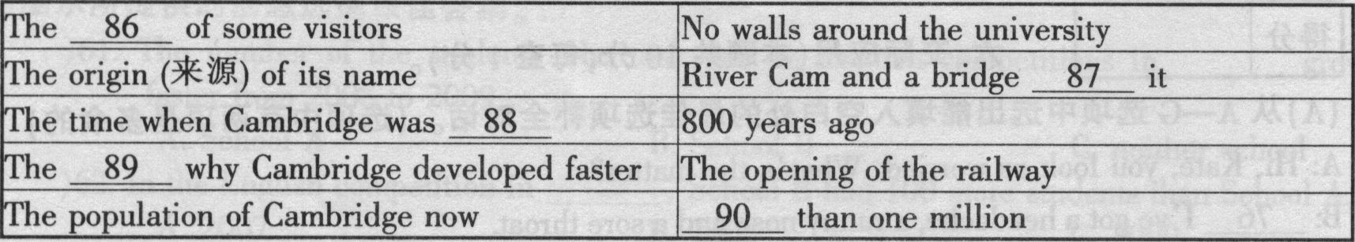
8 6．______ 8 7．_______ 8 8．______ 89．______ 90．_______
【答案】86．surprise 87．over 88．founded 89．reason 90．More
（六）（2009吉林通化）
水上公园为青少年提供有趣的假日工作机会，如果你对此感兴趣并希望在假期丰富自己的生活，请仔细阅读并完成下面的招聘广告，每空一词。（5分）

INTERESTING VACATION JOBS FOR TEENAGERS
--- Help out at Children’s Water Park

Are you ___96___at water sports? Do you like kids? Can you speak English?
We need young people ___97___ can talk to the visitors at the Park and show them around. We also look for people who can ___98___kids to swim and play water games___99___ them. There are also some animals in the Water Park that need care and attention.
Do you like to have this ___100___ job? If you do, please write and tell us about
your experiences. You may call Ms. Smith at 720-8491.
【答案】96. good 97. who 98. teach 99. with 100. vacation/ wonderful/interesting/ excellent
（七）（2009辽宁锦州）
①_____________
THE Earth is about 4,600 million years old．Many of the things that we have done are good，but many more are not good for the Earth．
Pollution is②(地球上的一种严重问题)．In big cities Car and buses have polluted the air．Many people in cities now have very bad health problems．
③(工厂也对土地和水造成了污染)．As a result, many rivers and lakes are flOW polluted．All over the world，people have cut down millions and millions of trees．Did you know many kinds of animals and plants are now disappearing(消失)?In particular, flees are very important ④because they produce oxygen (氧气)and control the climate．
Now, many people are beginning to take these problems seriously．They are making wind generators(发动机)and planting new flees．There is a group in our class that picks up the garbage at school．Whether the weather is hot or cold we always do it．⑤I think we are setting a good example to everyone else．
I hope，in the future，the sky can be clearer, the water cleaner, and the land greener．Then both people and animals can have a greener Earth．
1．请在①出给出文章的题目。
2．请把②的汉语翻译成英语。
3．请把③的英语翻译成汉语。
4．请把④的画线部分翻译成汉语。
5．请把⑤的画线句子翻译成汉语。
【答案】 1．Greener Earth(本题开放度较大，凡是能够表达“地球”、“污染”、“绿色环保”思想的，只要表达正确都得分) 2．a serious problem on the earth/in the world 3．Factories have also polluted the land and the water． 4．因为他们制造氧气并且控制气候 5．我想我们正在给其他人树立好榜样
（八）（2009深圳市）
请你根据某学校的一个广播通知，填写下面的海报。
May I have your attention, please? I have an announcement to make．
Since the A/H1Nl flu is around us, we should pay great attention to our health and get some knowledge about the terrible disease．Our school has invited Doctor Li to give us a talk about how to prevent(预防)the flu．It will start at 4：00 on Friday aftemoon in our school lecture hall. Students in Grade Seven are required to attend the talk．Please be there on time．
That’s all．Thank you.
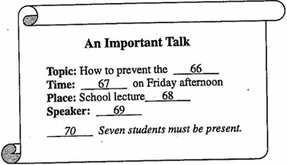
【答案】66—70 A/H1N1 flu; 4:00; hall; Doctor Li; Grade
（一）（2009山东泰安）阅读下面的短文，并完成短文后的任务。
Waste can be seen everywhere in the school. Some students ask for more food than they can eat and others often forget to turn off the lights when they leave the classroom. They say they can afford these things. But I don’t agree with them.
Waste can bring a lot of problems. Although China is rich in some resources (资源), we are short of others, for example, fresh water. It is reported that we will have no coal or oil to use in 100 years. So if we go on wasting our resources, what can we use in the future and where can we move? Think about it. (3) I think we should say no to the students who waste things every day. Everybody should stop wasting as soon as possible.
In our everyday life, we can do many things to prevent (阻止) waste from happening, for example, turn off the water taps when we finish washing, turn off the lights when we leave the classroom, try not to order more food than we need, and so on. Little by little, everything will be changed. (4) Waste can be stopped one day, if we do our best.
任务1：根据要求答题。(请注意问题后的词数要求)
1. List the wastes mentioned in the first passage: (within 15 words)
_________________________________________________________________
2. What problems can waste bring? (within 20 words)
(1) ______________________________________________________________
(2) ______________________________________________________________
任务2：将短文中划线的句子翻译成汉语。
3. ______________________________________________________________
4. ______________________________________________________________
任务3：请给短文拟一个适当的标题：(within 5 words)
5. ______________________________________________________________
【答案】1. ask for more food，forget to turn off the lights
2. (1) We’ll be short of resources.(fresh water, coal or oil.)
(2) We’ll have nothing to use and nowhere to move./What can we use in the future and where can we move?
3. 我认为我们应该对那些天天浪费东西的学生说不。
4. 如果我们都尽力的话，将来有一天浪费就不会发生了。
5. Stop wasting/No more wasting
（二）（2009宁波）在生活中，我们经常会遇到一些令人不愉快的事情，应该如何解决呢?以下是网站www.fyv.com 提供的几个问题及其解决办法，请你给予合理的配对。
Problems:
1. Some people always smoke in public places.
2. The No. 16 bus is always late.
3. Some people always drop litter everywhere in our neighborhood.
4. Some students talk loudly in the library.
5. My parents hope I stay at home and study all day, even at weekends.
Solutions:
A. Tell them that we need to relax after studying for a long time or ask our teacher for help.
B. Tell them politely to keep quiet.
C. Put up some posters to ask them not to litter. If someone is found dropping litter, punish him badly
D. We could say politely "Excuse me, could you please put out your cigarette?"
E. Call the bus company and ask for the better service.
【答案】1. D 2. E 3. C 4. B 5. A
（三）（2009绍兴）
运动前的热身活动有助于肌肉放松，也能避免受伤。请阅读１－５题有关热身活动的文字，然后从Ａ、Ｂ、Ｃ、Ｄ和Ｅ中选择符合文字内容的图示，并将答案写在对应题号的横线上。
1. Activity 1
◇ Hold arms straight out to the siders
◇ Move your arms in circles.
◇ Come back to the starting position and move your arms in the other direction.
2. Activity 2
◇ Raise one foot backward, and hold it with one hand.
◇ Breathe and slowly pull your foot to your hip(屁股).
◇ Try to keep both knees together.
3. Activity 3
◇ Stand with some space in front of and behind you. Move the top of your body downward.
◇ Keep your back straight and reach for your feet with both hands.
◇ Hold this for about half a minute.
4. Activity 4
◇ Take one step forward with your right foot.
◇ Put your hands on the right knee and press(压).
◇ Do the acton in the same way with your left foot.
5. Activity 5
◇ Stand with feet shoulder-width apart(两脚与肩同宽).
◇ Raise both arms overhead.
◇ Hold for about half a minute and relax.
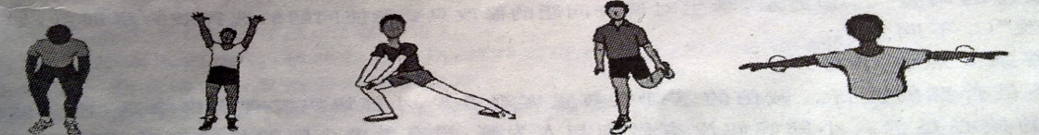
A B C D E
【答案】1-5 EDACB
（四）（2009福州）
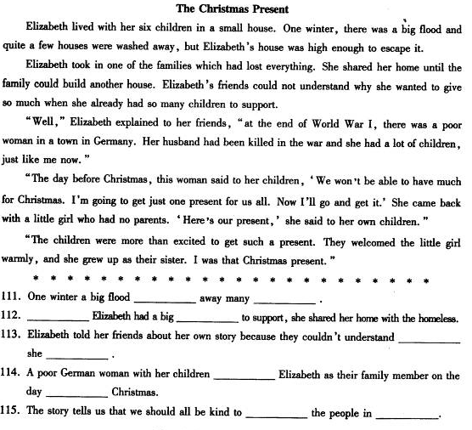
【答案】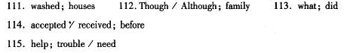
（五）（2009临沂）
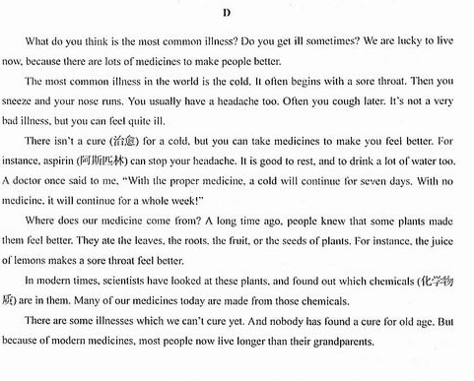
句子翻译
精讲一、根据中文补全句子
（一）（2009甘肃兰州）
1. 尽管我学习不好，但我从未放弃过。
___________I didn’t do well in my lessons, I _________ gave up.
2. 鲍勃将跳远的世界纪录保持了多久？
How long did Bob __________ the world __________ in the long jump?
3. 听到那悲伤的消息，他忍不住哭了。
He couldn’t ________ ________ when he heard the sad news.
4. 当我到达火车站时火车已经开走了。
The train ________ ________ when I got to the train station.
5. 如果每个人都能为保护环境做出自己的贡献，这个世界将变得更加美好。
The world will become much more beautiful if everyone ________ a contribution to ________
the environment.
答案1. Though/Although, never 2. hold/keep, record 3. help crying 4.had left/gone
5. makes, protecting

(二）（2009山东淄博）
根据汉语意思用英语完成句子，将答案写在横线上。
86. 我们应该排队等候上公共汽车。
We should to get to the bus.
87. 杰克逊喜欢与别人交朋友。
Jackson likes with others.
88. 学生在校时间必须穿校服。
Students wear school uniforms school days.
89. 上星期天我们玩得很痛快。

答案 86. wait, in, line 87. making, friends 88. have, to, on
89. Last Sunday we had a good time.

（三）（2009山东省烟台）
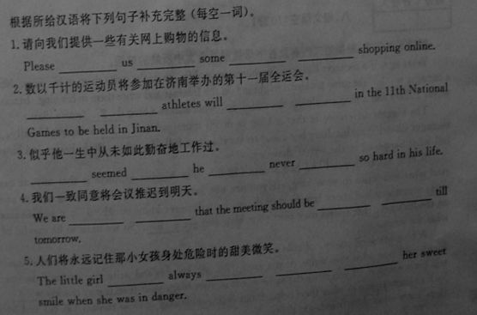

答案


（四）（2009扬州市）

根据所给汉语完成下列句子，词数不限。（共6小题；第71—73小题每空1分，第74—76小题每空3分，计15分）
71. 同学们对他的工作表现非常满意，结果都推荐他获今年的青年奖。
The classmates ▲ the performance of his duties. ▲ , all of them recommend him for this year’s Youth Award.
72. 顺便问一下，你去过扬州几次了？
▲ , how many times ▲ Yangzhou?
73. 看了刘谦的表演，许多孩子对魔术着了迷。
Many children have ▲ magic since ▲ Liu Qian’s show.
74. 为了举办今年的4·18晚会，工人们用了不到一个月就搭year’s 4·18 Entertainment Show.
75. 老师常常叫我们不要整天忙于做作业。建了一座水上舞台。
It ▲ a stage on water to hold this
The teacher often tells us ▲ .
76. 为什么不学会与你的家人分担烦恼呢？
▲ your family members?
【答案】
（一）（2009福州）

【答案】
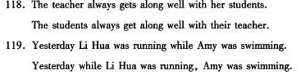
（二）（2009湛江）
按照所给汉语意思完成句子，注意语法正确，意思完整，词数不限。
1. 到目前为止，这些士兵已经救了一百多人。
________________, these soldiers have saved more than one hundred people.
2. 雨下得这么大，你最好呆在家里。
It is raining hard, and you ___________________ at home.
3. 我们为中国将主办第29届奥运会而感到自豪。
We __________________ China which will host the 29th Olympic Games.
4. 如果我明天有空，就和你下棋。
If I __________________ tomorrow, I ______________________ with you.
5. 当你学习遇到困难时，请不要放弃。
Please ______________________ when you have difficulties in study.
【答案】1. So far 2. had better stay 3. are proud of /take pride in
4.have time/am free, will play chess 5. don’t give up

