Unit2 The United Kingdom

教学内容分析:
本单元主要话题是“英国”。 通过阅读使学生了解英国的历史和地理位置，国家的构成及名胜古迹。
本单元所涉及的要点是：
（1）了解，认识英格兰，威尔士，苏格兰和北爱尔兰。
（2）了解伦敦的一些著名景观。
（3）学习过去分词作宾语补足语的句型。
（4）掌握与人交流语言理解有困难时请求别人重复的几 种表达方式。

The 1st Period ( Reading )
Teaching Aims:
Enable the students to know the UK in geography and history.
Teaching Important Points and Difficult Points:
How to understand the geographic puzzle of the UK.
Teaching Methods:
Skimming and task-based activities.
Teaching Procedures:
Step I Warming up
- Background knowledge:
Name: The United Kingdom of Great Britain and Northern Ireland
Countries: England, Scotland, Wales, Northern Ireland
Capital: London
Location: Western Europe
Population: 60,441,457 (July 2005)
Language: English, Welsh, Scottish
Ethnic groups: English 81.5%, Scottish 9.6%, Irish 2.4%,
Welsh 1.9%, Ulster 1.8%, West Indian, Indian, Pakistanis, and other 2.8%
Area: Total 244,820 sqk.
Climate: Temperate: moderated by prevailing southwest over the North Atlantic Current; more than one-half of the days are overcast
Natural resources: Coal, petroleum (石油), natural gas, iron ore, lead (铅), zinc (锌), gold, tin, limestone (石灰岩), gypsum (石膏)
Task 1: Describe briefly the UK according to the map.
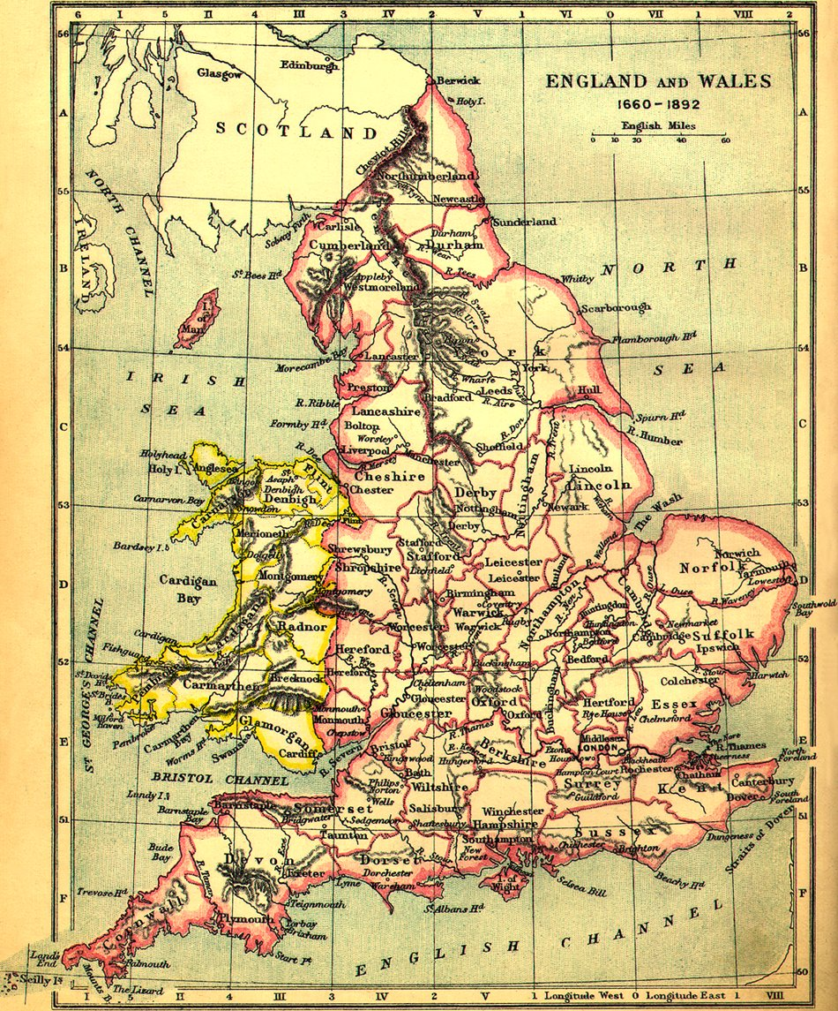
1.The UK is surrounded by water in all sides.
2. On the west of the Great Britain lies the Irish Sea .
3. On the south of England lies the English Channel .
4. On the northeast lies the North Sea .
5. On the north is the North Atlantic Ocean .

- Task 2
Ss do the quiz on page 9.

Step II. Pre- reading
Task 3. Ss discuss and answer the following questions.
- Can you name the capital cities of the countries of the UK?
- England can be divided into three main areas. Do you know what they are?
3. What do you know about any cities or towns in the UK?

Step III. While-reading
Task 4. Read the title and predict what the text will tell you.
Task 5. Talk about the different flags of the countries of the UK
Task 6. Skimming
According to the text, join lines to the right answer.
Para. 1. Explains the joining of England and Wales.
Para. 2. States topic to be examined in the reading.
Para. 3. Explains the importance of London as a
cultural and political centre in the UK.
Para. 4. Explains what the term “Great Britain”
means and how it came about.
Para. 5. Explains differences in the four countries.
Para. 6. Explains how England is divided into three
zones.
Task 7. Answer the questions
1. The Union Jack flag unites the three flags of three countries
in the United Kingdom. Which country is left out? Why?
__________________________________________________
2. What three countries does British Airways represent?
- ________ 2. ________ 3. __________
3. Which group of invaders did not influence London?
________________________________________________
Task 8. Ss read and get the general idea of the parts

Step IV. After-reading
Write a short summary of the passage.
The writer examines how the UK developed as an administrative unit. It shows how England is also divided into 3 zones. It explains why London became the cultural capital of England.

Step VI. Homework assignment
1. Read the whole passage and retell.
2. Go to the net to get more information about UK.

The 2nd Period (Language points)
Teaching Aims:
- Learn expressions & phrases
- Learn language points
Teaching Important Points:

Language points
Teaching Difficult Points:
Have /get sth. Done
Teaching Methods:
Presentation & Practice
Teaching Procedures:
Step I Revision

Retell the passage.
Step II. Expressions & phrases
Expressions & phrases (1)
- consist of 由…组成
- divided into 分开
- There is no need (for sb.) to do…
- debate about sth. 为…争辩（争论）
- refer to 提及，谈到
- connect to /link to 连接
- as well (as ) 也，还有
- to one’s (great) surprise 使…吃惊
- find sb./ sth. done (doing) 发现某人（物）处于某种状态下
- get sb. / sth. done
11. break away (from) 挣脱
12. break down （机器、车辆）坏
13. for convenience 为了方便
14. be known as/ for /to /by
15.keep one’s eyes open 睁大眼睛
16.make sth. worthwhile 使… 值得
17.leave out 省去；遗漏；不考虑
18. find out 发现
19. on the phone 在电话里
20. be on holiday 在度假
21. in memory of 为了纪念
22. leave for 动身去某地
23. ring out 发出响声，响起
24. make a list of 列出…的清单
25. pass through 通过
26. be on show 在展出
27. take the place of 代替，取代
28. remain doing 仍然在做…
29. on (special) occasions 在（特殊） 场合
30. feel / be proud of 为…而自豪
31. fall asleep 睡觉
Step IV. Language Points
- consist of ＝ be made up of 由….组成 (没有进行时）
eg: The UK consists of Great Britain and Northern
Ireland.
＝Great Britain and Northern Ireland make up the UK.
The soup consists of tomatoes, meat and peas.
consist in = lie in 存在与；在于(无被动形式)
eg: The beauty of air travel consists in its speed
and ease.
consist with: 一致
The report consists with facts.
2. 区别:
separate …from (把联合在一起或靠近的人或物分离出来）
divide…into 把…分开 （把整体分为若干部分）
eg: The teacher divided the class into two groups.
eg: The Taiwan Strait separates Taiwan from Fujian.
- As we joined the big crowd, I got ______ from my friends.
A. separated B. spared C. lost D. missed
3. There is no need to do sth 没必要做某事
eg: There is no need for you to help him.
There is no need to worry at all.
4. debate about sth.
eg. They debate about the proposal for three days.
debate /argue/ quarrel
5. clarify: vt./vi. (cause sth. to )become clear or easier to understand 澄清；阐明;清楚；明了
eg. I hope what I say will clarify the situation.
Can you clarify the question?
6. be linked to = be connected to /be joined to
- This wire connects _____ that one.
A. with B. to C. of D. on
7. refer to
- 提及，指的是…
eg: When he said “some students”, do you think he
was referring to us?
2) 参考；查阅;询问
eg: If you don’t understand a word you may refer to
your dictionaries.
Please refer to the last page of the book for
answers.
3) 关系到；关乎
eg: What I have to say refers to all of you.
This rule refers to everyone.
- It was foolish of him to _____ his notes during that
important test, and as a result, he got punished.
- stick to B. refer to C. keep to D. point to
reference: n. reference book
8. join A to B /link A to B 把A和B连接
eg: The Channel Tunnel will join Britain to Europe
by road.
9. included /including
10. name: n. v.
11. to one’s surprise
(prep)
“to one’s +名词” 表 “令某人…”
常见的名词有 “ delight, disappointment, enjoyment;
astonishment 等
eg: I discovered, to my horror, that the goods were
entirely unfit for sale.
To John’s great relief they reached the house at
last.
12. …found themselves united peacefully
“find +宾语＋宾补( adj; adv; v-ing; pp; 介词短语；
不定式）”
eg: A cook will be immediately fired if he is found
smoking in the kitchen.
You’ll find him easy to get along with.
They found themselves trapped by the bush fire.
When I woke up, I found myself in hospital.
I called on him yesterday, but I found him out.
13. get sth done =have sth done 使某事被做
eg: I'll just get these dishes washed and then I'll
come.
get + n. + to do
get + n. + doing
eg. You’ll get her to agree.
l’ll get the car going.
get done: 用于意想不到、突然或偶然发生，意为“被….”
- Be careful when you cross this very busy street.
If not, you may _____ run over by a car.
A. have B. get C. become D. turn
14. break away (from sb / sth) 脱离；破除…
eg: It is not easy for him to break away from bad
habits.
The man broke away from his guards.
break down (会谈)破裂，失败；(汽车等)出故障;
(人的健康状况)变得恶劣；（情感）失控
eg. His car broke down on the way to work this
morning.
His health broke down under the pressure of work.
He broke down and wept when he heard the news.
Talks between the two countries have completely
broken down.
区别：break in 闯入;打岔 break off 中断，折断
break into 闯入 break out 爆发;发生
break up 驱散;分散,拆散
- News reports say peace talks between the two
countries_____ with no agreement reached.
A. have broken down B. have broken out
C. have broken in D. have broken up
15. as well as 不仅…而且; 既…又…
eg: He is a teacher as well as a writer.
The children as well as their father were seen
playing football in the street.
16. relation: 关系；亲戚
eg. The cost of this project has no relation to the
results.
He is a close relation of mine.
17. convenience: n.方便；便利
We bought this house for its convenience.
convenient: adj.
be convenient to sb.
- come and see me whenever ___________.
- you are convenient
B. you will be convenient
C. it is convenient to you
D. it will be convenient to you.
18. be known as 作为…(身份)出名
be known for 因…而出名
be known to 为…所知
be known by 根据… 得知
eg: Fu Biao is known to everyone as a good actor.
He was known for his frankness.
19. attraction:
un. 1). 吸引；引力
cn. 2). 吸引人的东西；喜闻乐见的东西；精彩节目
Eg. attraction of gravitation 重力
He can’t resist the attraction of the sea on a hot
day.
A big city offers many and varied attractions.
What are the principle attractions this evening?
attract : v.
attractive: adj.
unattractive: adj.
attractively: adv.
20. influence
- (v) 对…产生影响
eg: What influence you to choose a career in
teaching?
2) (可数n) 产生影响的人或事
eg: He is one of the good influences in the school.
3) (不可数n) 影响
eg: A teacher has great influence over his pupils.
21. invader: n. 入侵者；侵略者
invade: vt. 侵入；侵略；挤满；涌入
eg. Doubts invade my mind.
Disease invades the body.
22. evidence (不可数n) 证据;迹象
a piece of evidence 一项证据
eg: He got many pieces of evidence from the
internet for his theory.
evidence: 指谋事的真伪
proof: 指令人信服的、无可置疑的证据
There wasn’t enough ________ to prove him guilty.
His fingerprints were ________of his guilt.
23. keep one’s eyes open 睁大双眼
24. Which country is left out?
*leave out: 省略;遗漏;排除
eg: Do you know which word in this sentence has
been left out?
Don’t leave me out when you’re giving out the
invitations!
25. take the place of 取代，代替
=take one’s place / replace
in place of
instead of instead
give place to 让位于…
in place / out of place 在适当/ 错误的位置
a place of interest

Step VI Homework assignment

The 3rd Period (Learning about language & reading)
Teaching Aims:
- Enable the students to plan a tour around certain places.
- Help the students know more about the historical sites in London.
Teaching Important Points and Difficult Points:
Help the students identify different kinds of tour and talk about the most interesting place for the tour.
Teaching Methods:
Task-based activities.
Teaching Procedures:
Step I. Discovering useful words and expressions
- Ss do Ex 1 on page 11.
- Ss finish Ex 2 on page 12.
Suggested answer:
- debate, puzzle, conveniences, clarify, legal, kingdom, attraction, influence
2. whispered, asked, smiled, screamed, begged, agreed, answered, shouted, complained, suggested, decided, advised

Step II. Reading
Task 1: Read and answer the following questions.
- How did Zhang Pingyu plan her tour?
- What were the buildings mentioned in the text?
What were they famous for? Who built them?
What happened to them?
Keys:
1. First, she made a list of the sites she wanted to see. Then she planed her four-day trip.
2.
1).Tower, built by Norman invaders of AD 1066, it is a
Solid, stone, square tower which remained standing
for one thousand years.
2). St Paul’s Cathedral, built after the terrible fire of
London in 1666, looked splendid;
3). Westminster Abbey, contains statues in memory
of dead poets and writers;
4). Greenwich, the longitude line;
5). Big Ben;
6). Highgate Cemetery;
7). The library of the British Museum
8). Windsor Castle
Task 2: Read and fill the information in the form.
Day 1 | Comments | Day 2 and  comment | Day 3 and comment
1. Tower | 1. delight | Greenwich with: ships  Longitude line clock (GMT) | Karl Marx’s statue  “strange he lived and died in London”  British Museum  “thrilled to see Chinese pottery”
2. St Paul’s cathedral | 2.splendid | Greenwich with: ships  Longitude line clock (GMT)
3. Westminster Abbey | 3. interesting, full of statues of poets and writers | Greenwich with: ships  Longitude line clock (GMT)
4. Big Ben | 4. famous and very loud | Greenwich with: ships  Longitude line clock (GMT)

Step III. Language points
1. available: adj.
(物) 可用的，可得到的
（人）可会见的，可与之交谈的
eg. These tickets are available today.
The doctor are available now.
be available for 有空做…；可供…利用
2. make a list of 列…的清单
3. delight :n. 高兴，愉快
v. 给人乐趣，使愉快; 引以为了
eg. He laughed with delight.
I was delighted to be invited to her party.
She delights in cooking.
delighted: adj. 高兴的
delightful: adj. 令人喜悦的，令人快乐的
be/feel delighted at/with/by 因…而高兴
to one’s delight /joy 令人高兴的是…
4. remain doing sth
remain: 1).vi. 剩下；留下；
2). Link-v. continue to be 继续保持，仍然
Much work remained to be done.
I’ll remain to see the end of the match.
The door remained closed.
It remained raining.
5. on special occasions 在特殊场合
6. in memory of … 纪念…
eg: He founded the charity in memory of his late
wife.
7. ring out: 发出响声，响起
8. It seemed strange that …should have lived…
He seems to be …
There seems to be ….
9. feel proud of
Step IV. Homework assignment

The 4th Period (Grammar )
Teaching Aims:
Enable the students to use the past participle as the object complement.
Teaching Important Points and Difficult Points:
Learn to use the past participle as the object complement.
Teaching Methods:
Task-based activities.
Teaching Procedures:
Step I. lead-in
Task 1: Ss try to analyse the following sentences
- I think the job easy.
- We make him monitor.
- I saw a boy crying over there.
- We heard someone go into the room.
- My mother allows me to watch TV after I finish my homework.
Step II. Grammar: The Past Participle as the Object Complement
Task 2: Try to find the function of the italic words.
- So many thousands of terrified people died.
- The polluted water was to blame.
- He became inspired when he thought about helping ordinary people.
- He got interested in the second theory.
- She found the door broken in when she came back.
- He kept the door locked for a long time.
- I have my hair cut.
Task 3: Please find the sentences from the text with past participles used as the object complement.
- Now, when anyone refers to England you find Wales included as well.
- So to their surprise the three countries found themselves united…
- …they were going to get Ireland connected to the other three….
Step III. Practice
Task 4: Practice
Ss finish the Ex 2 on page 12.
Suggested answers:
- have got the house mended
- have you had your hair cut?
- have the dictionary delivered
- haven’t had the film developed
- found it closed
- put it repaired
- got all their money stolen
- had some flowers sent, had it announced, had it organized
Step IV. Summary
Task 5: Summary：
Past participle used as the object complement
Ss use the following words to make up sentences with past participles as the object complement and summarize the structures.
- keep the door ( lock);
leave the window (break )
I will keep the door locked when I leave my room.
Don’t leave the window broken like this all the time.
- keep /leave + n. /pron. + p.p
2. have the bike (repair);
get the work (do);
I have had my bike repaired.
We had better work harder to get the work done on time.
- have /get + n. /pron. + p.p
3. make yourself (hear);
make myself (understand)
Can you raised your voice to make yourself heard?
I managed to make myself understood.
- make + oneself + p.p
4. see the door (lock);
hear the windows (beat)
When we got to the shop, we saw the door locked.
We can hear the windows beaten by the heavy rain drops.
- 感官动词：watch/ notice/ see/ hear/ listen to/ feel /find 等
+ n. /pron. + p.p
5. with his hands (tie);
with many flowers (plant) around the building
The thief was brought in with his hands tied behind his back.
With many flowers planted around the building, his house looks like a beautiful garden.
- with + 宾语+ 宾补（pp/ -ing/adj. / adv./ to do…）
Task 6: Practice
1. Do Wb. Ex 1 on page 50.
2. Do Ex 2. on page 51.
Step V. Homework assignment

Step IV. Homework assignment

The 5th Period (Listening & speaking)
Teaching Aims:
- Improve the students’ listening skills.
- Improve the students’ speaking skills.
Teaching Important Points:

Listening
Teaching Difficult Points:
Help Ss overcome the difficulties in listening material.
Teaching Methods:
Task-based activities.
Teaching Procedures:
Step I. Pre-listening
Show the Ss a map about the relations of the Kings.
King Edward IV 1457-1483
King Edward V 1486-1486
King Richard III 1483-1485
King Henry VII 1485-1509

King Henry VIII

Edward VI Mary Elizabeth I
1547-1553 1553-1558 1558-1603

Step II. Listening
Task 1. Listen and finish Ex 1 on page 15.
Task 2. Listen and fill in the blanks in the following passage.
These two princes were _________and _______six hundred years ago. They had come to London for the older brother to be crowned _______after his father, King Edward IV,_____. He was only thirteen years old. His wicked uncle, Richard, was supposed to ___________them both, but instead he had them _______while they were_________.
In the 1550s when queen Elizabeth I was still a___________, her sister, Queen Mary, brought her to the Tower as a ________because she thought Elizabeth was a traitor. She ________through a special gate________ “Traitors Gate” . That only ___________to very bad people.
Keys:
Brothers, lived , King, died, look after, killed, asleep
Princess, prisoner, went in, called, happened
Task 3 : Ss listen to the tape again and answer the questions on page 15.
Step III. Speaking and Listening (page 48)
The aim of this exercise is to show how history has affected those who can become British citizens.
Task 4: Ss in groups discuss what kind of person can be British.
The rules are fixed in this way:
1. If your parents were born in the old British Empire and they chose to become British when that country gained independence, you are a British citizen. If your parents chose to become citizens of the new country, then you have to apply for British citizenship.
2. If one of your parents is British and they were married at the time, you are a British citizen.
3. If you were born in the UK (even though your parents have a different nationality) you are a British citizen.
4. If you have no connection with Britain (either through your parents or the country your were born in) but have lived in the UK for five years, you can apply to become a British citizen.
Task 5: Ss listen to the tape and do Ex 2
Task 6 : Ss listen again and fill in the following form on page 48.
Group 1 | Group2 | Group 3
Born in the old British  Empire and asked to be a  British citizen | Having parents one of whom is British or having been born in the UK | Asking to become British after living in the UK for five years

Step IV. Homework assignment

- I beg your pardon? Pardon?
- What did you mean by…?
- I didn’t understand…
- I’m sorry but could you repeat that?

Step II. Writing
Writing
Task 2: Ask the Ss to rewrite the sentence:
The temple was build long ago.
Ss work in groups of five. Each group has a sheet of paper. The first person write the sentence with one improvement (either a verb or an adjective.) pass it to the next person who keeps the first change and makes a second one. Then the third person does the same. And so on to the end of the team.
Possible changes:
- The old temple was built long ago.
- The old temple was built two hundred years ago.
- The old temple was constructed two hundred years ago.
- The temple was burnt down early last century.
- The temple was rebuilt in 1980’s.
Task 3: Ss in groups write a guide book about an interesting building or attraction in your hometown.
Writing tips:
- Ss look at the model on page 16.
- Ss make a writing plan.
- Ss collect the words they will use.
- Ss begin to write their guide book.
- Read through their guide book and correct the mistakes.
- Rewrite it again.

The 6th Period (Reading , listening and speaking )

Teaching Aims:
- Improve the students reading skills.
- Learn something about Guy Fawkes Night.
- Improve the students listening and speaking skill.
Teaching Important Points and Difficult Points:

Reading Comprehension.
- Talk about the history story about UK.
Teaching Methods:
Task-based activities.
Teaching Procedures:
Step I. Reading (page 51)
Reading task
Task 1: Ss read the passage and fill in the Timeline on page 52
October | November
10 Catesby asked Guy Fawkes to join a plot to blow up the government. | 5 King James had the cellars searched when he heard of the plan. He found Fawkes
27 The two bought a house close to the Houses of Parliament
27 The two bought a house close to the Houses of Parliament | 6 Parliament was opened and there were celebrations because the plot had failed.
28-31 They stored gunpowder in the cellars for the next three days.

Step II. Listening task (page 52)
Task 2. Listen and finish Ex 1 on page 52.
- King James was a Catholic.
- King James was frightened of Catholic.
- King James supported Protestants.
- He punished Guy Fawkes.
- Guy Fawkes talked to King James.
6. The king thought the Catholics wanted to kill him.
7. The king rewarded Guy Fawkes.
8. The king thought there were too few Catholics.
9. The king’s friends abroad were Protestants.
Keys: F, T, T, T, F, T, F, F, T.
Task 3 : Ss listen again and answer the questions of Ex 2 on page 53
Step III. Speaking task
Do you think Guy Fawkes or King James were right to behave the way they did? The purpose of this exercise is to help you understand the story
and then decide who you feel most sympathy for. There is no right or wrong answer. Discuss this problem in fours and make notes of your ideas. Then decide who gets your sympathy and give a reason.
Reasons for King James’ action | Reasons for Guy Fawkes’ action
1. Fear at the number of Catholics | 1. King James kept changing his mind
2. All friends on the Continent were Protestant | 2. Loyalty to the Catholic cause
3. Worried Catholics might want to change the religion of England | 3. Believed what he was doing was right

Step IV. Homework assignment

The 7th Period (Speaking and writing)
Teaching Aims:
Improve the students’ writing & speaking skills.
Teaching Important Points:
Enable the students to write a short passage about a place of interest they have visited.
Teaching Difficult Points:
How to describe a famous building or a place of interest.
Teaching Methods:
Task-based approach.
Teaching Procedures:
Step I . Speaking
Task 1: In pairs choose an interesting building or attraction in your hometown or home village. One of you will be the tourist and the other the tour guide.
Try to use the following expressions while speaking:
- Excuse me… I’m afraid I can’t follow you.
- Please, can you speak more slowly?
- I beg your pardon? Pardon?
- What did you mean by…?
- I didn’t understand…
- I’m sorry but could you repeat that?

Step II. Writing
Writing
Task 2: Ask the Ss to rewrite the sentence:
The temple was build long ago.
Ss work in groups of five. Each group has a sheet of paper. The first person write the sentence with one improvement (either a verb or an adjective.) pass it to the next person who keeps the first change and makes a second one. Then the third person does the same. And so on to the end of the team.
Possible changes:
- The old temple was built long ago.
- The old temple was built two hundred years ago.
- The old temple was constructed two hundred years ago.
- The temple was burnt down early last century.
- The temple was rebuilt in 1980’s.
Task 3: Ss in groups write a guide book about an interesting building or attraction in your hometown.
Writing tips:
- Ss look at the model on page 16.
- Ss make a writing plan.
- Ss collect the words they will use.
- Ss begin to write their guide book.
- Read through their guide book and correct the mistakes.
- Rewrite it again.

