2009年初中毕业生学业考试绍兴市英语试卷

试卷Ⅰ（选择题 共85分）
（一）听力部分 （共25分）
一、听力（本题有15小题，第一节每小题1分，第二、三节每小题2分，共计25分）
第一节：听对话，选择图片。
1. What does the man want?
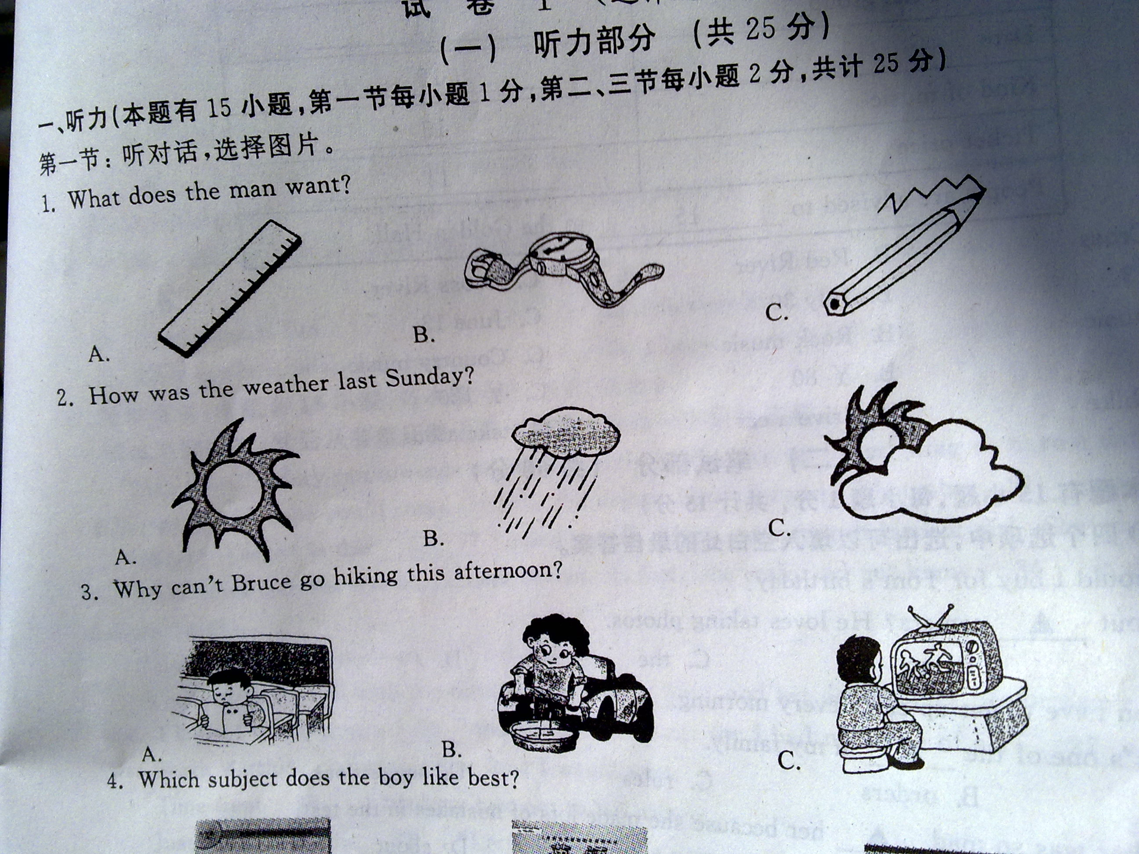
2. How was the weather last Sunday?
3. Why can’t Bruce go hiking this afternoon?
4. Which subject does the boy like best?
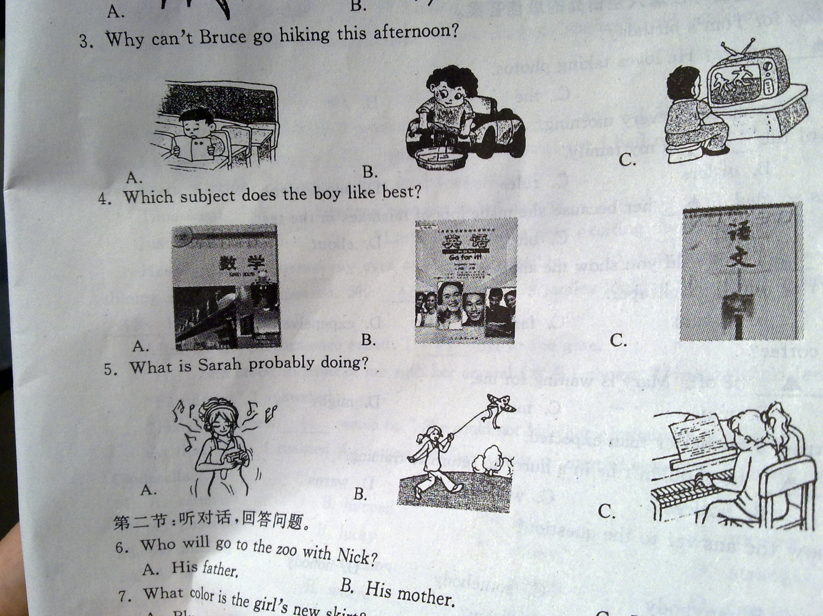
5. What is Sarah probably doing?
第二节：听对话，回答问题。
6. Who will go to the zoo with Nick?
A. His father. B. His mother. C. His sister.
7. What color is the girl’s new skirt?
A. Blue. B. Red. C. Green.
8. Where are the two speakers talking?
A. In a classroom. B. In a library. C. In a park.
9. When will the girl leave for Shanghai?
A. Next Monday. B. Next Friday. C. This Friday.
10. What does the conversation tell us?
A. The woman may have the wrong phone number.
B. The man doesn’t want to talk with the woman.
C. The two speakers know each other.
第三节：听独白，从A、B、C三个选项中选择正确的选项，完成信息记录表。
Concert Information Form
Name of the group | 11
Date | 12
Kind of music | 13
Ticket price | 14
People are advised to 15 to the Golden Hall.
11. A. Red Cross B. Red River C. Cross River
12. A. July 13 B. July 30 C. June 13
13. A. Pop music B. Rock music C. Country music
14. A. ￥40 B. ￥80 C. ￥120
15. A. ride a bike B. drive a car C. take a bus
（二）笔试部分 （共60分）
二、单项填空（本题有15小题，每小题1分，共计15分）
从A、B、C、D四个选项中，选出可以填入空白处的最佳答案。
16. –What should I buy for Tom’s birthday?
- How about _______ camera? He loves taking photos.
A. a B. an C. the D. /
17. – I hear you have to get up early every morning.
-Right. It’s one of the _____ in my family.
A. plans B. orders C. rules D. suggestions
18. Linda’s teacher was so mad ________ her because she made lots of mistakes in the test.
A. at B. in C. on D. about
19. – This skirt is too _______ . Would you show me another one?
- OK. Please try this one. It’s cheaper.
A. personal B. special C. famous D. expensive
20. –Another cup of coffee?
-No, thanks. I _____ be off. Mary is waiting for me.
A. can B. may C. must D. might
21. – Yao Ming is getting a lot better than expected.
-But his doctor_______ he shouldn’t be in a hurry to return to training.
A. imagines B. notices C. wonders D. warns
22. – Does ________ know the answer to the question?
-Me.
A. everybody B. anybody C. somebody D. nobody
23. – Would you like to go bike riding with us tomorrow?
- Sure, ________ I am busy.
A. since B. unless C. when D. until
24. He always _____ his friends about everything. In fact, he has no thoughts of his own.
A. agrees with B. plays with C. deals with D. talk with
25. – Did you go to the flower show in the City Square?
-No. I ____ how to make food then.
A. learn B. learned C. was learning D. am learning
26. The whole world is fighting against the H1N1, a disease ______ has caused many deaths.
A. who B. which C. whom D. what
27. –Emily, here’s a dictionary. I hope it will help you.
-Thank you. It’s ______ what I need.
A. just B. still C. only D. almost
28. – Is Jack in the library?
- Maybe. I saw him ______ out with some books just now.
A. going B. go C. to go D. went
29. –Oh, I have lost my CD!
-______. Let’s call the lost-and-found first.
A. Don’t shout. B. Take it easy. C. Forget it. D. No chance.
30. –I’m going to visit my aunt this evening.
-________.
A. That sounds fun B. It’s very kind of you.
C. Give my best wishes to her. D. I hope it won’t be long.
三、完形填空（本题有15小题，每小题1分，共计15分）
阅读下面短文，然后从各题所给的四个选项中选出一个最佳答案。
“Hi! John.” Mary ran towards me with a bright smile, saying, “I’m going to have a dance performance(表演) tonight. I hope you’ll come. Here is the ticket. Don’t forget!” Then she 31 in a hurry.
“What? Dance? Is that 32 ? ” I asked myself. Mary was not such kind of girl. She was quite 33 one. I had never seen her wearing colorful clothes. In fact, she really did not know 34 to dress up. What a terrible thing!
“I should go to, I must go to.” I thought.
I arrived at the hall with the ticket, fond my 35 and sat down. Her performance was the seventh one. I knew I would have a 36 time before her turn, for I had no sense of art, 37 her performance was worth watching, no matter how ling I would wait.
Time went 38 , I tried my best not to fall asleep.
Just then, came the 39 , “Let’s welcome the next exciting dance – Latin!”
Hearing this, I opened my eyes as large as possible, 40 to lose anything. Wearing a golden and shining skirt, Mary appeared. She 41 with a sweet smile, looking like a pretty butterfly flying…I could 42 believe my eyes.
After all the performance ended, I 43 her at the gate.
“Hi!” She stood in front of me with her crystal(水晶) shoes. “How do you feel?”
“Fantastic!” I answered.
“Ha, ha. I knew 44 would be.” She could not hide her excitement, laughing 45 a child.
At that time, I realized that every girl has a pair of special shoes which are like the crystal shoes of Cinderella.
31. A. came B. jumped C. left D. moved
32. A. possible B. lucky C. funny D. careful
33. A. modern B. common C. perfect D. careful
34. A. why B. where C. when D. how
35. A. seat B. room C. gate D. way
36. A. great B. short C. hard D. relaxing
37. A. or B. so C. but D. and
38. A. quickly B. slowly C. safely D. easily
39. A. words B. sentences C. sounds D. cries
40. A. hoping B. fearing C. planning D. hating
41. A. walked B. skated C. danced D. stood
42. A. seriously B. hardly C. nearly D. certainly
43. A. waited for B. looked for C. paid for D. cared for
44. A. I B. you C. she D. it
45. A. as B. like C. for D. at
四、阅读理解（本题有15小题，每小题2分，共计30分）
阅读下面四篇材料，从各题所给的四个选项中选出一个最佳答案。
A
- AC Milan star Kaka says a foot injury(受伤) is still stopping him from returning to football. He has not played for 32 days. Kaka says he is in a lot of pain. “I hurt myself in an area that we always put pressure(压力) on.” Kaka once played for a year with a knee injury, but the 26-year-old said this is much worse.
- British actress Emma used to spend more time filming than at school. But today she is ready to pay more attention to her studies. This 19-year-old girl will start at the Yale University in the autumn. “I always loved school. I just want to go back and find what else there is,” she said.
- Chinese 25-year-old sports star Liu Xiang returned to Shanghai in March. He had a successful foot operation(手术) in December in Houston, and spent the next three months there for recovery(康复) and basic training. It is said that a group of doctors are ready to help with Liu’s recovery.
- Russian great tennis player Sharapova will not be playing in the MPS Group Championships, which begins in the US on Monday. Sharapova was missing the Sony Ericsson Open the week before last in Miami. She may continue training for the WTA Rome event at the beginning of May.
46. Liu Xiang’s foot operation was successfully done in December in ________.
A. Miami B. Rome C. Houston D. Shanghai
47. How long has Kaka not played football because of his foot injury?
A. More than a month. B. About a year.
C. Two weeks. D. Three months.
48. Which of the following is RIGHT?
A. Emma started school at the age of 19.
B. Sharapova may play in the WTA Rome evernt.
C. Kaka was hurt by other players.
D. Liu Xiang returned to Shanghai for an ad.
49. Among the four persons, _______ isn’t a sports star.
A. Sharapova B. Liu Xiang C. Emma D. Kaka
B
A young man was getting ready to finish school. For a long time he had looked forward to getting a beautiful sports car. He knew his father could well afford it, so he told him that was all he wanted.
Then on the morning of his graduation(毕业) , his father called him into his private study. His father told him how proud he was to have such a fine son, and told him how much he loved him. He handed his son a beautiful gift box. Surprised, the young man opened the box and found a lovely Bible(圣经) with his name on it. Angrily, he raised his voice to his father and said, “With all your money you give me a Bible?” He then rushed out of the house, leaving the Bible.
Many years passed and the young man was very successful in business. He had a beautiful home and a wonderful family, but realizing his father was very old, he thought perhaps he should go to see him. He had not seen him since that graduation day. Before he could make arrangements(安排), he received a phone telling him his father had passed away. He had to come home immediately and take care of the things that his father left his father left him.
When he began to search through his father’s important papers, he saw the still new Bible, just as he had left it years ago. He opened the Bible and began to turn the pages. As he was reading , a car key with a tag(标牌) dropped from the back of the Bible. On the tag was the date of his graduation, and the words…”PAID IN FULL”. Sadness and regret filled his heart.
50. The underlined word “that” in Paragraph Ⅰ, means_______.
A. a car B. a box C. a Bible D. a phone
51. The young man was angry on the morning of his graduation because ________.
A. his fathere couldn’t afford a car B. he had to stay in his study
C. he thought he only got a Bible D. his father spent all the money
52. Which of the following isn’t mentioned in the third paragraph?
A. The young man succeeded in his business.
B. The yong man lived with his father all the time.
C. The young man decided to see his father.
D. The young man set up his own family.
53. It can be seen from the passage that the young man ________.
A. came to know the truth at last B. had to pay for the car himself
C. became interested in the Bible D. got angry with his father again
C
The holiday’s upon us. After months of study, you have some time to yourself. So, why not read a book? Well, some people will say, ‘Why trouble with books? We have the Internet and other media(媒体) that offer a lot more colorful programs. Books are history!”
But don’t be fooled. There’s still a lot to be said for reading-and reading as widely as possible.
One clear reason is that a well-chosen book is a wonderful collection of words and expressions, so long as you have a good dictionary, of course. Believe me, it’s far easier to get new English words and expressions from a book or article than it is from the TV or the Internet.
But an even more important point is that books give you something that modern media simply can not: The webpage(网页) is always full of pictures and the text is often designed(设计) to make it as easy to read as possible.
Though “easy” may be welcome, unluckily it’s of little use for any long-time development of reading skills and the general language level. For that, there’s still no substitute(替代品) for a book.
But perhaps the best single reason is that simply choosing what you read and doing it by yourself means that it’s something you do by and for yourself. You can choose what you want to read. It’s hard work, but while you are reading, you’ll find that what once seemed like a duty is now a pleasure.
54. Compared with the Internet, a well-chosen book can help us________.
A. spend our holiday as quickly as possible B. develop our speaking skills in a short time
C. get new words and expressions more easily D. make our life a lot more colorful than ever
55. The last paragraph mainly tells us that_______.
A. we should buy books by ourselves B. it’s easy to choose books
C. to read books must be our duty D. reading can bring us pleasure
56. The passage mentions ________ reason(s) why we should read books.
A. one B. two C. three D. four
D

My name is Lin Hui. I like to tellstories abut people who work together. What is even better is when countries help each other and build a good friendship. An excellent example of this happen when Britain and China worked together to bring the Milu deer back to China.

Milu deer, a kind of animal with large horns(角), used to be common in China long ago. Like other deer they lived together and ate grass and the soft parts of trees. Milu deer were often killed for food or sport. The Ming and Qing dynasties(朝代) did not protect them and many were killed. That is how the Milu deer disappeared from China.
Luckily before all of them were killed, some were takedn to Britain to improve the environment of the beautiful park which belonged to the Duke of Bedford(贝德福特公爵). He liked them so much that he took them from China to Britain. Milu deer liked the cool, wet weather in England and their number increased year by year. As a result, when in 1985 the government of China wanted to bring back the Milu deer, the Duke of Bedford was able to help. The first deer came back to China to the Nanhaizi Milu park 20 kilometers south of Beijing and the centre in Dafeng, Jiangsu province.
The deer certainly seem happy to be back in China because their number has grown quickly. There are now so many of them that a new park has been opened for them in Hubei Province. At the moment the Milu deer live in centres where they are being well protected and cared for. It is hoed that one day there will be enough animals to let them live in the wild (野外) again.
57. The Milu deer disappeared long ago in China because____________.
A. they could find nothing to eat B. they were not well protected
C. they died of a serious disease D. they had the habit of living together
58. After some of the Milu deer were taken to Britain, _________.
A. they didn’t like the weather there B. their number became larger and larger
C. people used them to carry things D. the Duke of Beford sold them all
59. We can lean from the passage that ____________.
A. China has three centres for the Milu deer now
B. the Mulu deer live on nothing but grass
C. all the Milu deer live in the wild now
D. the first Milu deer returned to China before 1985.
60. What’s the best title of the passage?
A. The number of the Mulu deer B. The life of the Milu deer
C. The return of the Milu deer D. The importance of the Milu deer
试卷Ⅱ(非选择题 共３５分)
五、词汇运用（本题有１０小题， 每小题１分，共计１０分）
阅读下面短文，然后根据括号内所给汉语的意思写出单词的正确形式（每空一词）。
Now some women are spending a weekend at Mother’s Camp. There, husbands and children are 61 (拒绝). Why would a woman want to take a vacation without her family? Some women say they need time to be 62 (单独的).
At Mother’s Camp a woman has a room for 63 (她自己). She can sleep, read or watch TV 64 (自由地). No children will ask, “Mom, what’s for dinner?” No husband will say, “Oh, dear, I can’t find any 65 (干净的) socks.” In fact, 50% of women in the United States work 66 (在……外面) the home. Many of them work full-time and then come home to a 67 (第二) job-taking care of their homes and families. These working women say one of their 68 (最大的) problems is housework.
In the United States, working women do about 75% of the housework. Many of their husbands say they want to help. But they ask so many questions that their 69 (妻子) decided it is easier to do the job themselves.
Some women go to Mother’s Camp just to relax away from home. They enjoy warm, sunny weather, 70 (躺) on the grass, flying kites or boating in a lake. They have a really wonderful vacation at Mother’s Camp.
六、任务型阅读（本题有５小题，每小题１分，共计５分）
运动前的热身活动有助于肌肉放松，也能避免受伤。请阅读７１－７５题有关热身活动的文字，然后从Ａ、Ｂ、Ｃ、Ｄ和Ｅ中选择符合文字内容的图示，并将答案写在对应题号的横线上。
71. Activity 1
◇ Hold arms straight out to the siders
◇ Move your arms in circles.
◇ Come back to the starting position and move your arms in the other direction.
72. Activity 2
◇ Raise one foot backward, and hold it with one hand.
◇ Breathe and slowly pull your foot to your hip(屁股).
◇ Try to keep both knees together.
73. Activity 3
◇ Stand with some space in front of and behind you. Move the top of your body downward.
◇ Keep your back straight and reach for your feet with both hands.
◇ Hold this for about half a minute.
74. Activity 4
◇ Take one step forward with your right foot.
◇ Put your hands on the right knee and press(压).
◇ Do the acton in the same way with your left foot.
75. Activity 5
◇ Stand with feet shoulder-width apart(两脚与肩同宽).
◇ Raise both arms overhead.
◇ Hold for about half a minute and relax.
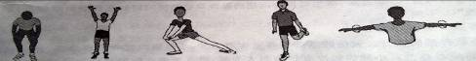
A B C D E
七、书面表达（本题有２小题，７６小题５分，７７小题１５分，共计２０分）
桥
76. Eric是一位来自美国的交换生，你和他约好今天去参观太空博物馆。由于Eric不熟悉周围环境，请你根据图示告诉他去太空博物馆的路线，并提醒他不要迟到。
Eric, it is easy to find the Space Museum. Just go across the _________ near our school. Walk down the street, _____________ at the first crossing. Walk on, you’ll see the Space Museum. It’s ____________ the restaurant. Please ___________________.

太空博物馆
解 放 路
河
小
超市
学 校
图书馆
动物园
公园
饭店

77. 你在和Eric的交流中了解到中美两国课堂有各自不同的一些特点，请你根据下表简要描述这些特点，并就此谈谈自己的想法。
 | 中国课堂 | 美国课堂
特点 | - 不称呼老师的姓名  - 仔细听讲、做笔记  - 举手发言 | - 学生面对面就座  - 比较放松，可以喝饮料  - 自由谈论
你的想法 | ……
要求：⑴ 文章必须包括表中所有信息，可适当增加细节，细不要逐条翻译；
⑵ 想法必须在２个句子以上；
⑶ 文章的开头已给出（不计入总词数），你只需接着写；
⑷ 词数在８０左右。
There are some differences between a Chinese class and an American class. Let' have a look. In China, _________________________________________________________________

_______________________________________________________________________________

_______________________________________________________________________________

_______________________________________________________________________________

2009年初中毕业生学业考试绍兴市英语试卷参考答案
- 听力部分
1-5 ABBAC 6-10 BCBAA 11-15 BAABC
- 单项选择
16-20 ACADC 21-25 DBBAC 26-30 BABBC
- 完形填空
31-35 CABDA 36-40 CCBAB 41-45 CBADB
- 阅读理解
46-50 CABCA 51-55 CBACD 56-60 CBBAC
- 词汇运用
61. refused 62. alone 63. herself 64. freely 65. clean
66. outside 67. second 68. biggest 69. wives 70. lying
- 任务型阅读
71-75 EDACB
- 书面表达
76. bridge, turn left, near/ across from/ by/ beside, don’t be late/ be on time
77. One possible version
There are some differences between a Chinese class and an American class. Let’s have a look. In China, students call their teachers with “Mr” or “Miss”. In class they always listen to teachers and take notes carefully. If they want to show their own ideas, they put up their hands first. However, in America, students sit around the desks, face to face. They have pretty relaxed rules. They can even drink coffeeor juice during classes. Aslo, they can speak out in class freely. Different countries have different cultures. But I think Chinese class is better. We should be strict in our study.

